Title: Escape Room: Crime and Trigonometry
Workshop description:
This workshop has been created for 11th grade students who are in a mathematics course. It is a fun way to challenge participants and have them apply the knowledge they’ve gained through their mathematics class in the context of a game. The workshop focuses primarily on the trigonometry unit. Throughout the workshop, participants will review the process of solving for angles or side lengths of a variety of triangles using diverse techniques. These techniques include:
- Special triangles
- Trigonometric ratios
- SOHCAHTOA
- Sine and Cosine laws
The workshop takes the form of an escape room, which means that participants will have to solve a sequence of problems to move from room to room before being able to “escape”. They will work in groups, to successfully complete the escape room.

Description of the authors of the workshop:
Professor Samia Challal is an associate professor with the Department of Mathematics at Glendon Campus, York University. Her research interests include homogenization, optimization, free boundary problems, partial differential equations and problems arising from mechanics.

Professor Samia Challal holds a master’s degree from Rennes University, France, where she was initiated for the first time to continuum mechanics and modelling. She then pursued a PhD at Metz University, France, and worked in the field of homogenization theory – a mathematical tool studying the macroscopic properties of a heterogenous medium from its description at the microscopical state. Professor Challal then explored the area of non-linear partial differential equations of filtration of a liquid or two through porous media and the study of regularity of solutions for obstacle problems. In her teaching, she is particularly motivated in bridging the mathematical tools introduced and their applications through modelling and numerical analysis.

York’s Experiential Education:
This workshop was developed by Tylar Robin, a second year Glendon student studying Mathematics with a minor in Philosophy. She intends on pursuing a career as a high school teacher. For this reason, when she completes her degree in mathematics, she will continue on to study Education.

Table of Contents
WORKSHOP OUTLINE 4
FACILITATOR NOTES 5
GOOGLE FORMS TEXT 8
SOLUTIONS SHEET (FOR FACILITATOR GUIDE) 10
EQUATION SHEET 18
RESSOURCES ET INFORMATIONS 20
GLOSSARY 21

OVERVIEW AND AGENDA

OVERVIEW
TRIGONOMETRY ESCAPE ROOM
Learning objectives:
- Develop problem-solving skills
- Review previously learned concepts in trigonometry
- Identify and apply the correct strategies to solve a series of trigonometry-based problems, including:
  - Special triangles
  - SOHCAHTOA
  - Sine and Cosine laws
  - Pythagorean Theorem
Materials required:
- Computer or tablet with access to the Internet
- Zoom
- Scrap paper and pencils

Length: 75 minutes

AGENDA
TIME | ACTIVITY
5 minutes | Introduction
 | Part 1 - Introduction of the game
10 minutes | Brief review lesson of the contents
 | Part 2 - Escape room
15 minutes | Activity 1 - Special triangles
15 minutes | Activity 2 - SOHCAHTOA
15 minutes | Activity 3 - Sine and cosine laws
 | Part 3 - Discussion
10 minutes | Discuss the activities present in the escape room
 | Conclusion
5 minutes | Questions et survey

WORKSHOP OUTLINE

Introduction (5 minutes)
- Objective: Create a comfortable environment before beginning the escape room and identify real-life applications of trigonometry.
- Description: Facilitators will present themselves and then give the participants the opportunity to present themselves through a short icebreaker activity.

Part 1: Introduction of the game (10 minutes)
- Objective: Explain the rules of the escape room game and review the math skills that will be necessary.
- Description: This part consists of a short lesson to outline the knowledge necessary to solve the problems within the escape room. Participants will be given a sheet with the formulas on it to use if necessary.
Part 2: Escape room (45 minutes)
- Objective: Review and reinforce the skills the participants acquired during their 11th grade trigonometry unit.
- Description: The participants will use the knowledge they gained in their math course to solve a series of problems in the form of an escape room-style game. In order to solve each problem, they will need to determine the appropriate trigonometry technique to use and apply it. Working in groups, they will solve problems related to the following concepts: triangles solved using special triangles, triangles solved using SOHCAHTOA, and triangles solved using the sine and cosine laws.
Part 3: Discussion (10 minutes)
- Objective: Clarify any problems from the escape room that were difficult and review key concepts.
- Description: When they complete the escape room, participants will have an opportunity to ask for explanations of difficult problems and the facilitator will go through some of the key concepts from the game. Participants will be encouraged to think of how trigonometry can be used in real-life.
Conclusion (5 minutes)
- Objective: Participants will be given the opportunity to ask any final questions or make any comments.
- Description: Participants will share any remaining questions or comments and be asked to complete a short participation survey.

FACILITATOR NOTES

Introduction [5 minutes]
- The facilitator will introduce themselves briefly, followed by a short icebreaker activity (such as, two truths and a lie, allowing the participants to present themselves as they guess what the lie is). Alternatively, the facilitator can poll the participants regarding their level of comfort with trigonometry.
- The facilitator will present the objective of the workshop.
- This workshop aims to allow participants to identify and associate the different techniques used to solve problems of trigonometry, including: special triangles, trigonometric ratios, SOHCAHTOA, and the sine and cosine laws. They will be doing so in the form of an online escape room.
- The facilitator will then prompt a short discussion with the participants about the real-life uses of trigonometry.
  - After the « triangles are everywhere » slide, the facilitator will ask the participants what kind of jobs may use trigonometry. Then, once the participants have had a chance to answer, the facilitator can present a couple of jobs briefly (e.g., animation) and then proceed to play the video on the slide.
Part 1: Introduction of the game [10 minutes]
- The facilitator will present the game and the rules.
  - The game takes the form of a virtual escape room set at the Louvre in Paris, and the objective is to steal the Mona Lisa before the time runs out. Participants will do so by successfully solving each problem in order. There are 9 problems in total. There is one bonus question at the end, which is not mandatory, but if participants successfully solve the bonus question, they will have 5 minutes taken off their total time.
  - The rules are as follows: Participants will have 45 minutes to complete the escape room in groups of 3-5. The answers must be put into the Google forms as just the number (no units) and rounded to two decimal places. If participants get stuck, they can receive one hint.
- The facilitator will now give a brief lesson on the knowledge necessary to complete the escape room. All the necessary information can be found directly on the PowerPoint slides.
Part 2: Escape room [45 minutes]
- The facilitator reads the following introduction to the escape room, before sharing the link (below):
  - It is the night of April 24th, 1986, the night that you attempt to rob the most famous Art museum in the world, the Louvre. Your primary goal is to steal the Mona Lisa. Can you do it? Or will you get caught and sent to jail? The rules are as follows: you must solve every problem presented to you in order. It is a race between you and the other thiefs, who will make it out first?
  - The facilitator now shares the link to the escape room with the participants: https://docs.google.com/forms/d/e/1FAIpQLSelRK0ezMGmUbGOqiHA7Kwlu9YZGxu0cTO2L_aUykjd6psxxw/viewform?usp=sf_link
You will complete your mission in groups of 3-5. You have 45 minutes to escape with the Mona Lisa. If needed, you have one hint that you can ask the facilitator for if you reach a question you cannot answer. As well, in your participant package there is an equation sheet and additional resources that can be used if needed. If you complete the escape room early there is a bonus question you can answer that will reduce your time by five minutes. Good luck and may the best thieves win!
- The facilitator will put the participants into groups (breakout rooms if on Zoom) of 3-5, depending on the size of the class. The facilitator will be able to visit each group throughout the escape room when and if necessary.
- Once the participants have received the link and have been put into groups, the facilitator can start the timer.
- If the participants need a hint, the “Solutions Sheet” at the end of the Facilitator Notes section has the problems and solutions for each of the questions. On the solution page for each question there is a section that tells the facilitator what to tell the participants when they ask for a hint for that problem. On Zoom, the breakout rooms have an “Ask for Help” button that participants can click to call the facilitator or moderator.
- There is a bonus problem at the end of the escape room that the participants will have the option of answering. If they successfully complete this question they will be prompted with a secret name (Leonardo da Vinci), which they will be told to send to the facilitator by direct message in the chat. When they do so their total time should be decreased by 5 minutes.
Part 3: Discussion [10 minutes]
- The facilitator will begin by allowing the participants to ask any questions that they may have regarding the escape room.
- Next, the facilitator will begin a discussion about what the participants saw in the escape room. They can begin this discussion by asking some of the following questions:
  - What types of questions were we asked to solve throughout the escape room? Was this a fun application for what you have learned in class? Prompts for facilitator to use if participants do not have answers:
    - To calculate heights (such as lasers)
    - To calculate distances (such as distances to jump)
    - To measure angles (such as flashlight angle)
  - What real-life applications of trigonometry did we see in this escape room? Prompts for facilitator to use if participants do not have answers:
    - Calculating sizes of objects to determine if something can fit somewhere
    - Determining if we can successfully reach certain distances
  - What kind of jobs may need to use trigonometry? Prompts for facilitator to use if participants do not have answers:
    - Computer animator
    - Architect
    - Civil engineer

Conclusion [5 minutes]
- The facilitator can now give a brief conclusion by summarizing key points and ask the participants if they have any last questions or comments they’d like to share. Afterwards, the facilitator will invite participants and the teacher to complete participation surveys (below).
  - Student survey (EN): https://forms.office.com/Pages/ResponsePage.aspx?id=GBNTNBFw1E-H8KQ4FsSb0EwfnQOE4vtJgtg6zg45P9ZURVlGTTNDWlZRUEZLMTU3T0pEWDFFWjUxQy4u
  - Teacher Survey (EN): https://forms.office.com/Pages/ResponsePage.aspx?id=GBNTNBFw1E-H8KQ4FsSb0EwfnQOE4vtJgtg6zg45P9ZUQUVZWVc0U0oyNDVZQTVBU1dWQUZORlQ5UC4u

GOOGLE FORMS TEXT
Introduction/instructions:
It is the night of April 24th, 1986, the night that you attempt to rob the most famous Art museum in the world, the Louvre. Your primary goal is to steal the Mona Lisa. Can you do it? Or will you get caught and sent to jail? The rules are as follows: you must solve every problem presented to you in order. It is a race between you and the other thieves, who will make it out first?
You will complete your mission in groups of 3-5. You have 45 minutes to escape with the Mona Lisa. If needed, you have one hint that you can ask the facilitator for if you reach a question you cannot answer. As well, in your participant package there is an equation sheet and additional resources, which can be used if needed. If you complete the escape room early, there is a bonus question you can answer that will reduce your time by five minutes. Good luck and may the best thieves win!
Problems:
Problem 1: You have made it to the Louvre but now must find a way inside. You are currently on the roof of the building and you spot an open window! The quickest way to get to the window would be to leap from where you are to the window instead of climbing down and then across. You are 1 meter above and 1 meter to the left of the window. You can only jump a maximum length of 2 meters. Using the measurements provided, will you be able to make the jump?
Problem 2: You have successfully made it inside! Look at all of the art! Check out this one. It feels like her eyes are following you. She is looking down at an angle of 60 degrees. If you are 1 meter below and $\sqrt{3}$ meters to the right of her, is she looking at you?
Problem 3: Oh no, a guard! You must hide from the light of his flashlight. Figure out what angle his flashlight is pointing at and stay below it! What angle must you remain below?
Problem 4: Here is the hallway you must travel through in order to get to the Mona Lisa, but it is full of laser beams! You notice a small opening below the lowest laser beam. Each beam is 2 meters long. Solve for the height of the laser beam so that you know how low you must duck in order to make it underneath. However, you can only duck as low as 0.5 meters without falling. Will you make it underneath the laser?
Problem 5: Since you were unable to make it through the first hallway you must try another route. This hallway has another booby trap! Arrows will shoot out of the wall when you enter. If the arrow is shot from 3 meters high and travels a horizontal distance of 5 meters, figure out what angle the arrows are aiming at so that you can avoid being shot.
Problem 6: While you are in the Louvre you may as well take a bit of time to check out the art. This may be a once in a lifetime opportunity after all. Look at that painting! Plenty of artists use angles and triangles to provide a balance in their art. What type of triangle is this artist using? Solve it and see!
Problem 7: One more hallway to make it through! You can only step on the red tiles that are above and two to the right of each other. The other tiles will collapse. You can jump a maximum of 2 meters. Will you make the leap?
Problem 8: We made it to the Mona Lisa! You must stay out of view of the camera. It is placed 7 meters high and can see up to 50 degrees away from the wall. How much of the ground is covered by the view of the camera. Solve it so that you know how much space you need to avoid.
Problem 9: Now that you have the Mona Lisa you just need to get the painting out of the window! The painting is 77 cm long and 53 cm wide. With the given values, will it fit through the window?
Problem 10: Bonus problem! Look at the beautiful glass building! Figure out the missing length and angle using the given information. Enter your answers as a comma-separated list: x, y

SOLUTIONS SHEET (FOR FACILITATOR GUIDE)

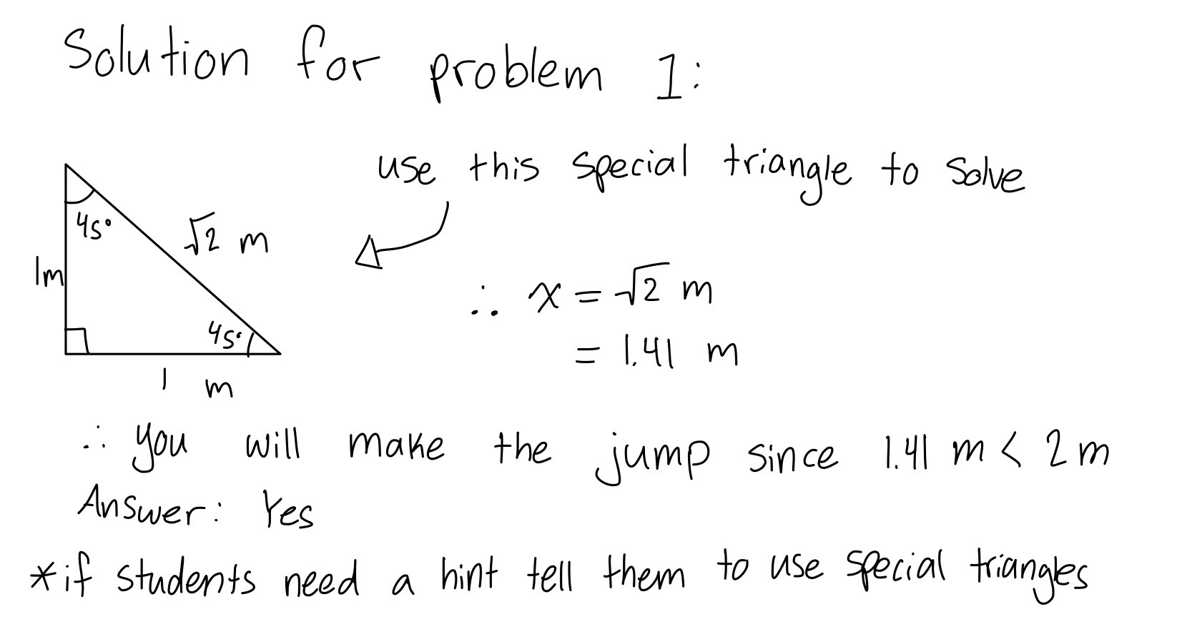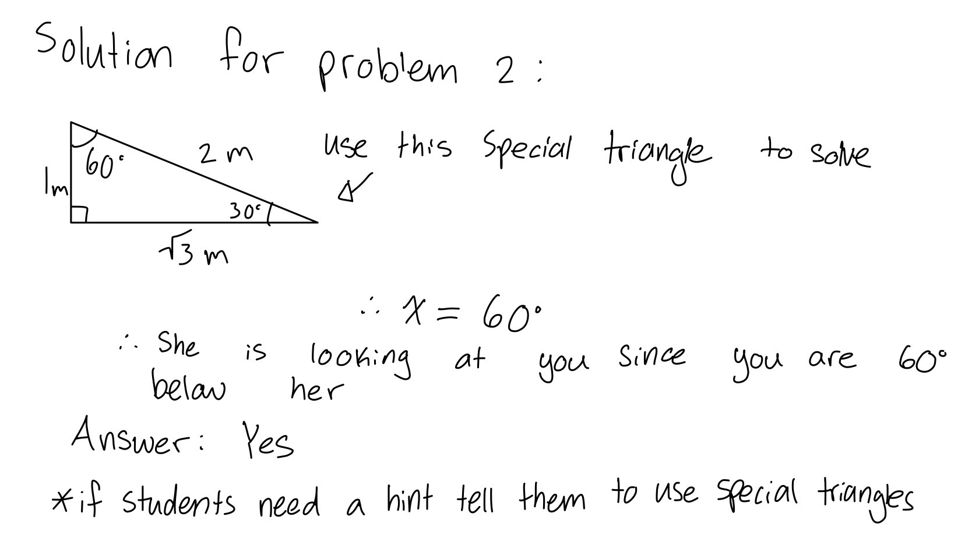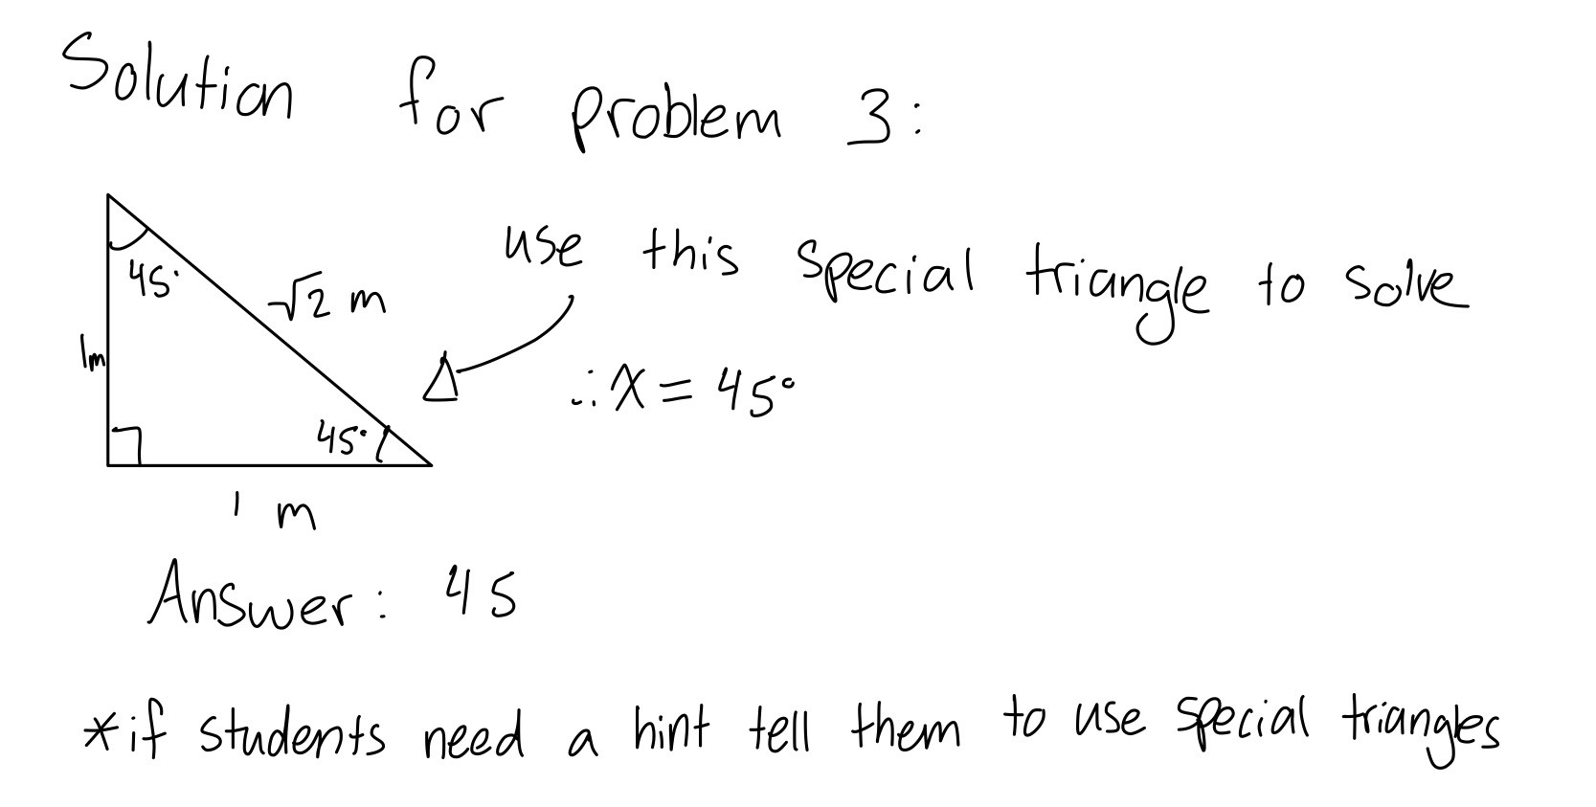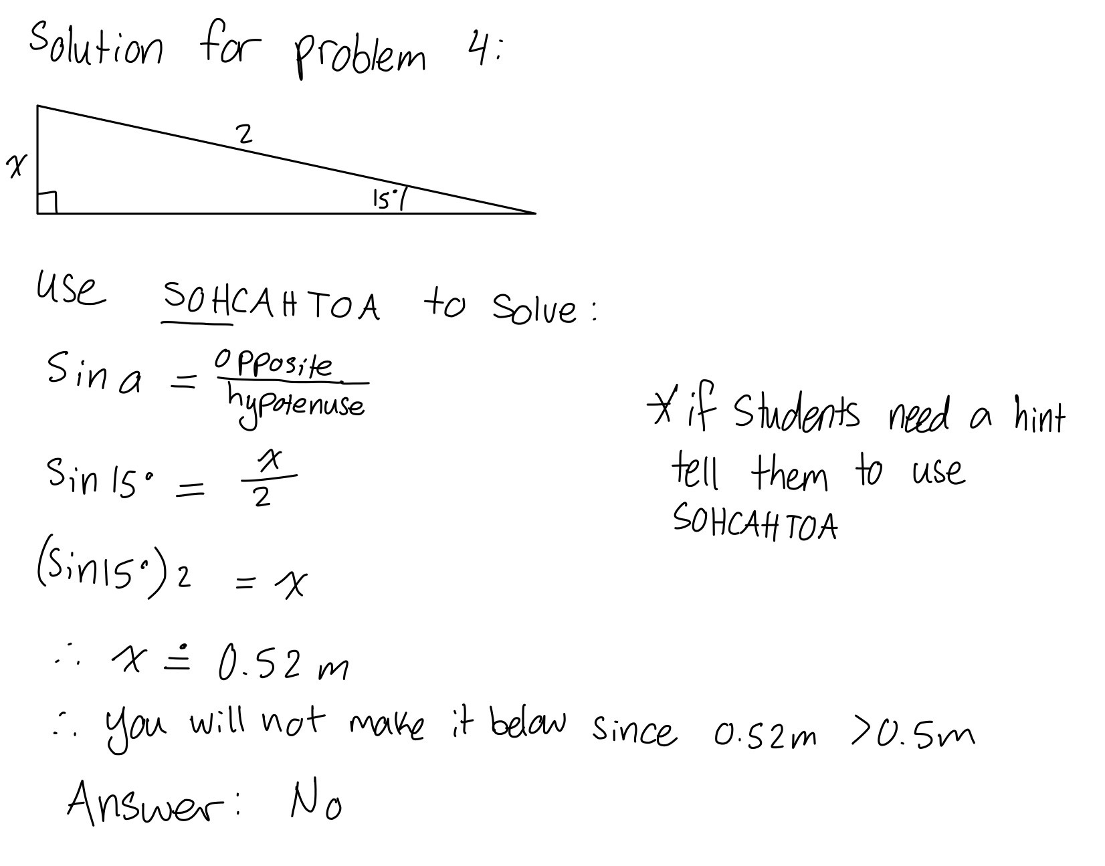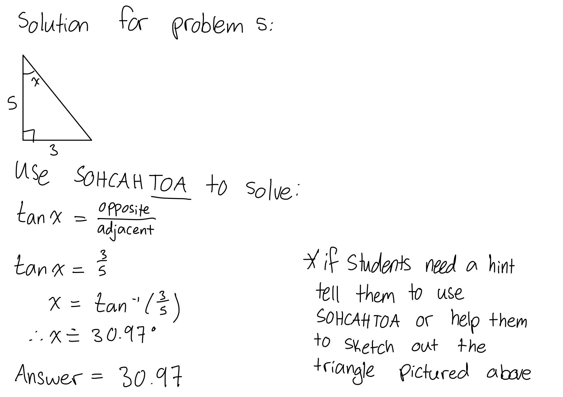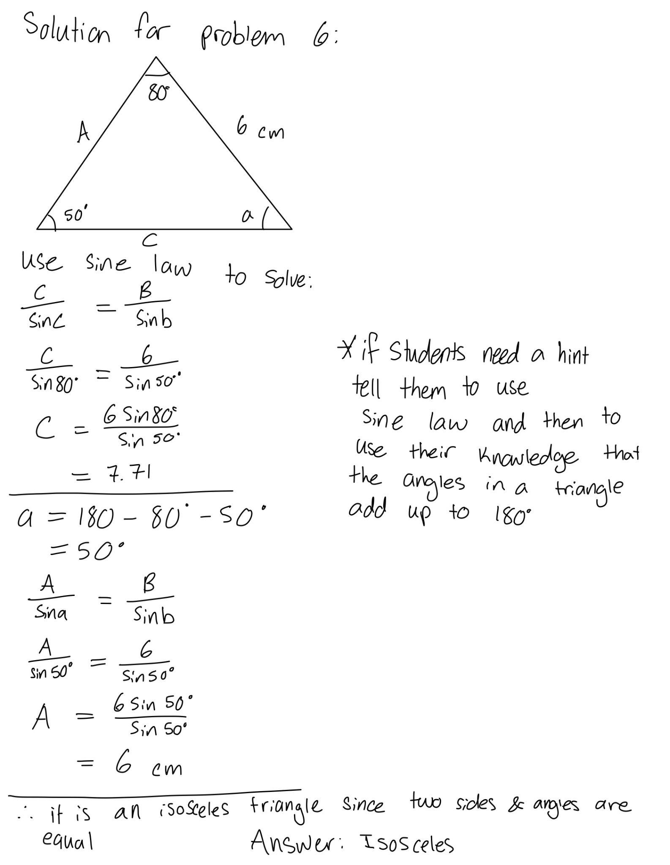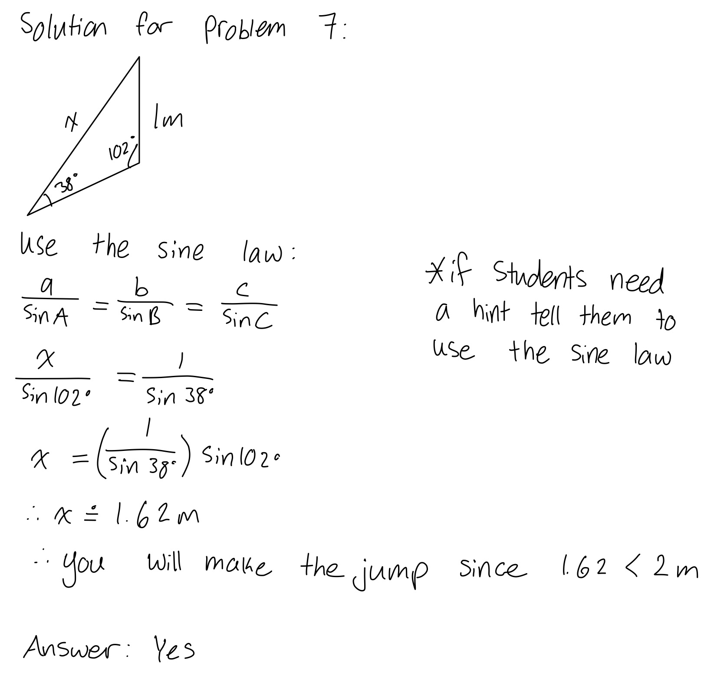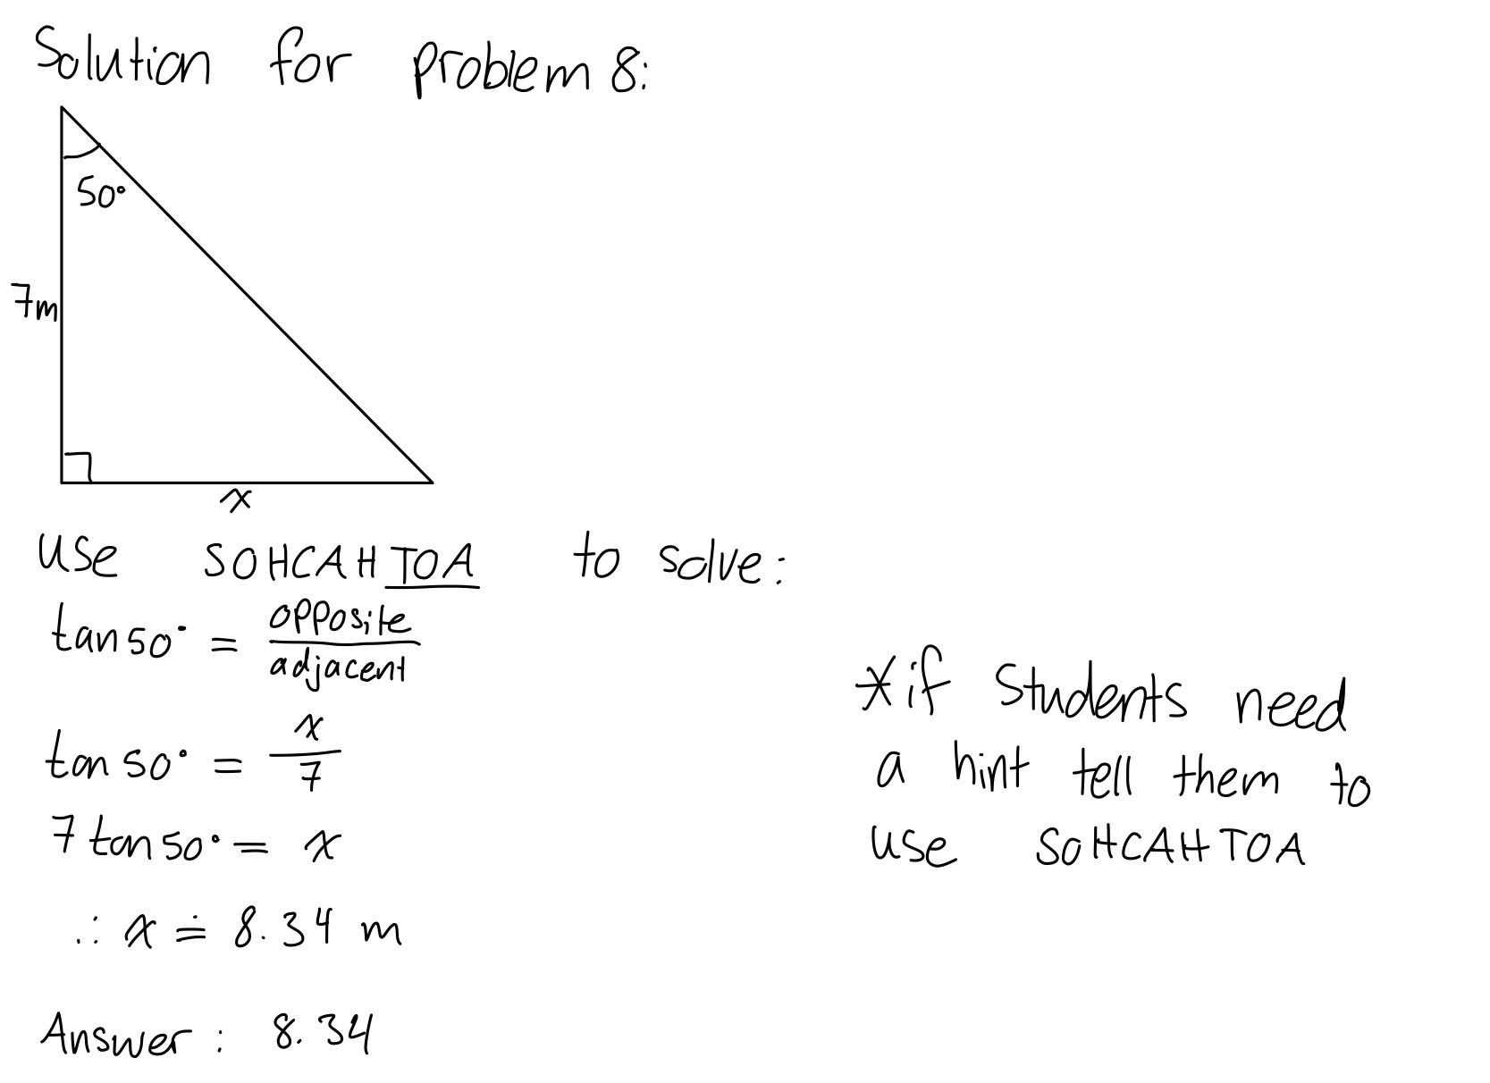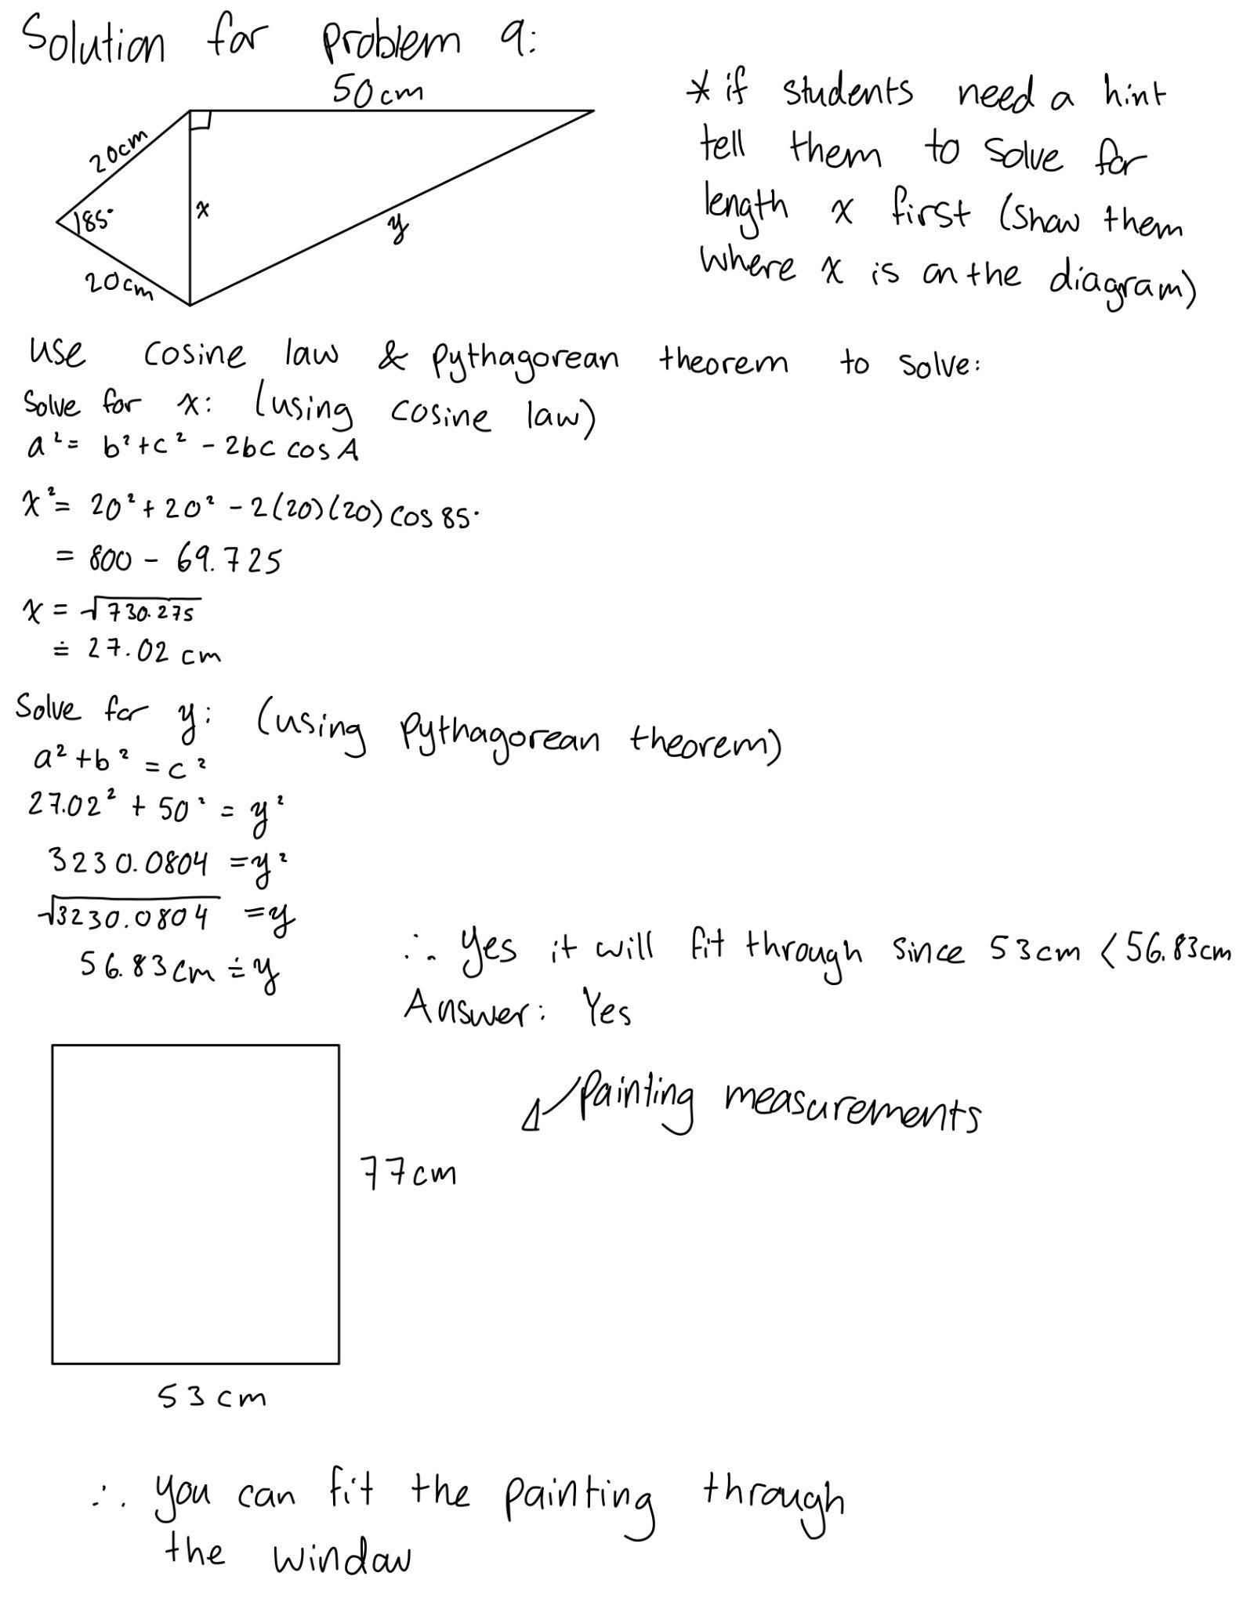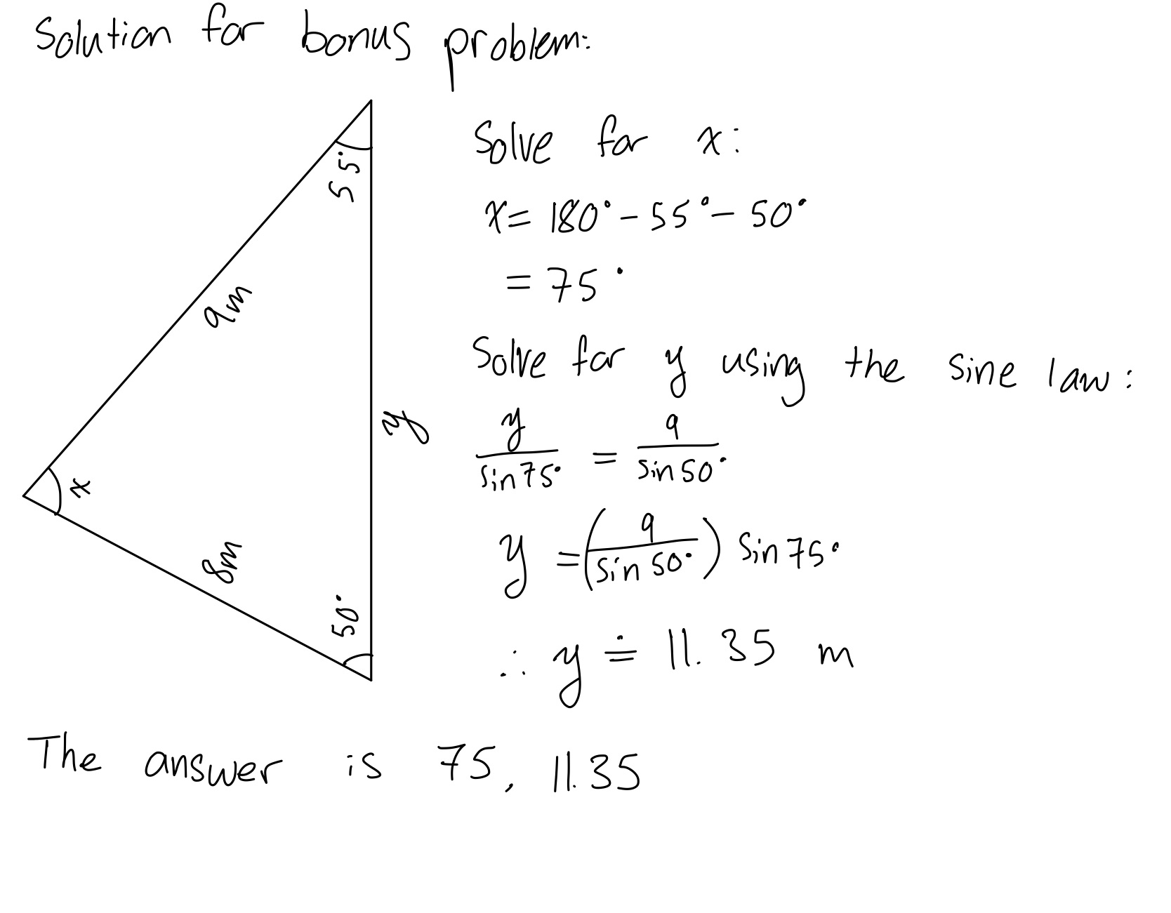

EQUATION SHEET
This equation sheet contains the necessary trigonometric formulas and information to complete the escape room. It also includes a description of each formula and its uses, to help you correctly apply the information presented.

Special Triangles:
Special triangles are certain right triangles that have special proportions for their sides that make calculations easier. They are commonly found in trigonometry and when recognized can be used to solve triangles instead of making additional calculations.
- When to use:
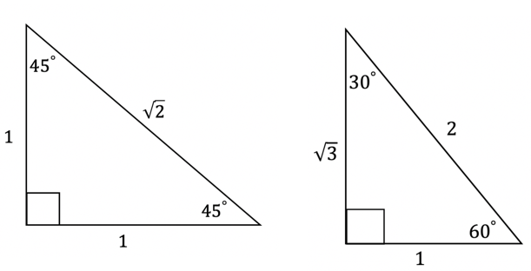
  - When you have a triangle with identical angles and proportions to the following triangles
Sine Law:
The Sine Law is a formula that represents the ratio between the sine of the angles and the lengths of a non-right triangle. It can be used to solve for the angles or lengths of non-right angles where a, b, and c represent the sides and A, B, and C represent the corresponding angles.
$$a÷sin(A)=b÷sin(B)=c÷sin(C)$$
$$sin(A)÷a=sin(B)÷b=sin(C)÷c$$
- When to use:
  - When you have a non-right triangle and are given either:
- two angles and one side opposite to one of those angles
- two sides and an angle opposite one of those sides
Cosine Law:
The Cosine Law is a formula that correlates the cosine of the angles and the lengths of a non-right triangle. It can be used to solve for the angles or lengths of a non-right triangle where a, b, and c represent the sides and A, B, and C represent the corresponding angles.
$$a^{2}=b^{2}+c^{2}-2∙b∙c∙cos(A)$$
$$cos(A)=(b^{2}+c^{2}-a^{2})÷2∙b∙c$$
- When to use:
  - When you have a non-right triangle and are given either:
- three sides
- two sides and the angle between them
SOHCAHTOA:
SOHCAHTOA is a mnemonic device used to remember the definitions of the trigonometric functions sine, cosine, and tangent. It is used for right triangles and it represents the following relations: SOH is sine equals opposite over hypotenuse, CAH is cosine equals adjacent over hypotenuse, and TOA is tan equals opposite over adjacent.
$$sinθ=opposite÷hypotenuse$$
$$cosθ=adjacent÷hypotenuse$$
$$tanθ=opposite÷adjacent$$
- When to use:
  - When you have a right-angled triangle that is not a special triangle

Pythagorean Theorem:
The Pythagorean Theorem is an equation that describes the relationship between the three sides of a right triangle. It states that the square of the length of the hypothenuse of a right triangle equals the sum of the squares of the lengths of the two other sides.
- When to use:
  - When you know the length of two sides of a right triangle and want to know the length of the third side.
$$a^{2}+b^{2}=c^{2}$$

RESSOURCES ET INFORMATIONS

Special triangles:
Khan Academy: Trig Ratios of Special Triangles
https://www.khanacademy.org/math/trigonometry/trigonometry-right-triangles/sine-and-cosine-of-complementary-angles/a/trig-ratios-of-special-triangles (English)
- This website describes special triangles and how to use them.

SOHCAHTOA:
Education Is Around: SOHCAHTOA
https://educationisaround.com/sohcahtoa/ (English)
Allô prof: Les rapports trigonométriques
https://www.youtube.com/watch?v=zPvzJsVFDgk&t=2s (French)
- Both the above links describe SOHCAHTOA and how to use it.

Sine and cosine laws:
Mathematics Online: Law of Sines and Cosines, Explanation
https://www.youtube.com/watch?v=3jBMymLI8ls (English)
Promath: Théorèmes du sinus et cosinus
https://www.youtube.com/watch?v=OCi2-OiwtaQ (French)
- Both the above videos explain the sine and cosine laws and how they are used.

Review of triangles:
New World Encyclopedia: Triangle
https://www.newworldencyclopedia.org/entry/Triangle (English)
Groupe 602, École de Normandie: Les triangles et les angles – révision
https://denormandiegroupe602.wordpress.com/2018/10/27/les-triangles-et-les-angles-revision/ (French)
- Both the above links give an overview of types of triangles and the field of trigonometry.

GLOSSARY

Adjacent: Having a common edge or boundary.
Angle: The space between two intersecting lines or planes.
Cosine: The ratio of a given angle’s adjacent side and the hypotenuse in a right-angled triangle.
Equilateral: A triangle where all three of its sides (and angles) are equal.
Hypotenuse: The side of a triangle that is opposite the right angle in a triangle.
Isosceles: A triangle where two of its sides (and angles) are equal.
Opposite: The side of a triangle that is opposite to a given angle.
Right-angled triangle: A triangle with one right angle (90 degrees).
Scalene: A triangle where all three of its sides (and angles) are different.
Sine: The ratio of a given angle’s opposite side and the hypotenuse in a right-angled triangle.
Tangent: The ratio of a given angle’s opposite side and adjacent side in a right-angled triangle.
Trigonometry: The branch of mathematics that deals with the relationship between the sides and angles of triangles.

York University’s Glendon Campus has been offering exceptional bilingual university education unique in Canada for over fifty years. Our commitment to education and bilingualism also extends
to our bilingual transitional programming for high school students. Learning a language is
rewarding and fun, even if it can sometimes be frustrating. Our programming is designed to give
students an opportunity to expand their vocabulary and learn important skills by participating in interactive workshops on financial literacy, leadership, urban geography, biology, psychology and a wide range of topics in the social sciences.

Our programming can be delivered to Francophone or Anglophone students in their mother tongue, or to Francophone and Anglophone students seeking to improve their second language
learning (FSL or ESL).

#LifeLongLearningBeginsHere #BeingBilingualRocks #BilingualNinja
Originally developed for in-person delivery, we are also able to deliver our programming remotely.
Contact us today to find out how we can help you keep your students educated
and engaged in and out of the classroom.

www.glendon.yorku.ca/brainboosting

Katie Ablett, MBA, PMP | katie.ablett@glendon.yorku.ca
Director, Continuing Education

Glendon Campus, York University
2275 Bayview Avenue, Toronto ON l Canada M4N 3M6 | www.glendon.yorku.ca

