Clarity, Impurity, and Discant Structure in Mesopotamian Music
Current Musicology 50th Anniversary Conference, Columbia University, NYC, March 28, 2015
Jay Rahn

The purpose of this report is twofold:
- to determine for Mesopotamian tuning what the contrast between zaku and la-zaku referred to;
- to show what the result of this determination is for understanding Mesopotamian music in general and, in particular, for analyzing the only pieces of Mesopotamian music that have survived.

For more than 40 years, the consensus view of ancient Near Eastern musicology has implicitly been that the Mesopotamian formulation of tuning specified:
- 7 named tunings for a harp or lyre,
- 7 pitch classes in each of these tunings, and
- among these 7 pitch classes an intervallic structure that was, to employ a term coined by Norman Carey and David Clampitt in 1989, ‘non-degenerate well-formed.’

With regard to the last point, which was first formulated explicitly for Mesopotamian tuning in 2011, Figure 1 illustrates how in each of the named tunings:
- 6 pairs of tones were instances of a single interval class, termed ‘zaku’ in the Mesopotamian tuning formulation, and
- the remaining pair of tones comprised an instance of the interval class termed ‘la-zaku,’ i.e., not zaku.

Also implicit in the consensus view has been the conclusion that each instance of the zaku and la-zaku interval classes was produced by a pair of strings that spanned 4 strings, or its inversion, 5 strings.

I agree with each of these aspects of the consensus view. However, the consensus view has also assumed that the intervals spanned by 4 or 5 strings were, respectively, 4ths and 5ths and that the resulting tuning was diatonic. In contrast, the Mesopotamian tuning formulation does not directly imply that intervals produced by pairs of strings that spanned 4 or 5 strings respectively spanned 4 or 5 scale degrees, i.e., that such pairs were, respectively again, 4ths or 5ths. Indeed, without contradicting their 7-pitch-class, non-degenerate well-formed structure, the intervals produced by such string-pairs might instead have been 2nds or 7ths, or they might have been 3rds or 6ths, and even if they were 4ths and 5ths, the resulting tuning might have been recognizably pelog in character rather than diatonic.

Figure 2 illustrates schematically the 6 possible ways in which a 7-pitch-class, non-degenerate well-formed structure might have been realized relative to an ideal octave interval of 1200 cents. Each of these 6 possible ways depends solely on the magnitudes of its zaku and la-zaku intervals.

For more than 40 years, scholars of Mesopotamian music have translated zaku as ‘clear’ and la-zaku as ‘not clear’ and have gone on to identify the clear intervals with particular ‘consonances,’ namely, perfect 4ths and 5ths and the ‘not clear’ intervals with particular ‘dissonances,’ namely, augmented 4ths and diminished 5ths. As a consequence, scholars have concluded that Mesopotamian tuning was diatonic and would correspond to the second possibility of the six outlined in Figure 2.

Nonetheless, Sam Mirelman has recently observed that ‘we cannot be sure that such an interpretation is correct.’ Indeed, he has written, ‘it seems uncomfortably familiar and Eurocentric.’ On this basis, Mirelman has cautiously proposed ‘to leave the question of the precise nature of the Mesopotamian tuning system open.’

To be sure, a binary opposition between consonant perfect 4ths and 5ths and dissonant augmented 4ths and diminished 5ths is simplistic. Even in European-derived music, not only perfect 4ths and 5ths have been regarded as consonances, but also 3rds and 6ths. Similarly, European-derived music has treated not only tritones but also 2nds and 7ths as dissonances. Moreover, for music in several traditions that have had no historical connection with each other or with the West, comparative musicologists have considered 2nds to be consonances.

Nonetheless, a very recent publication adds considerable certainty to what the adjectives zaku and la-zaku might have denoted with regard to 4- and 5-string intervals.

In his 2014 study of ‘The Semantics of Purity in the Ancient Near East,’ Yitzhaq Feder has identified contexts in which Mesopotamian languages employed adjectives associated with purity. Whereas musical scholars have translated zakû as ‘clear,’ its literary contexts suggest several closely related translations: ‘refined’ (as of metals), ‘released’ (i.e., from confinement, as of birds or persons), and ‘freed’ (as from legal claims). Such contexts involve a process of change: specifically, a single uninterrupted process of change from a lower to a higher value or valence. With regard to value or valence, Mesopotamian languages contrasted things that were zakû with those that were polluted, cloudy, or discoloured.

According to the Mesopotamian formulation of tuning, one changed a harp or lyre from one tuning into another tuning by tightening or loosening one string of a la-zaku pair of strings in the current tuning so that it became a zaku pair of strings in the new tuning. As this procedure was undertaken by ear, one can understand that such a transformation involved turning the interval produced by a certain pair of strings from being la-zaku in the sense of sounding—at least metaphorically—polluted, cloudy, or discoloured into an interval that sounded—again, metaphorically—unpolluted, non-cloudy, or not discolored: that is, one purified the sound produced by a particular pair of strings by tightening or loosening one of its strings.

What, then, constituted the pollution, cloudiness, or discoloration that one removed when changing a harp or lyre from one tuning to another? Rather than ‘dissonance,’ which can be understood in several ways, one could construe the pollution, cloudiness, or discoloration produced by a la-zaku pair of strings to have been a psychoacoustical phenomenon, namely, the perceived roughness that would have resulted from acoustical interference between partials of the spectrum produced by the two tones when a la-zaku pair of strings was plucked simultaneously.

Admittedly, there is much that we do not know about the acoustics of Mesopotamian harps or lyres. However, we can be quite certain that the first six partials of their tones had the greatest amplitudes. Accordingly, Figure 3 illustrates how roughness changes along with the magnitude of intervals whose tones comprise the first six partials of their harmonic spectra—like those produced by the plucked strings of a harp or lyre.

Comparing Figure 2 with Figure 3.a, one can observe that intervals of approximately 600 cents, which would be la-zaku in the second kind of tuning in Figure 2, would have much greater roughness than intervals of approximately 498 or 702 cents, which would be la-zaku in this kind of tuning. Consequently, a single uninterrupted process of loosening or tightening one of its strings would result in a minimum amount of roughness relative to intervals between these minima. For the intervals highlighted in Figure 3.a, these minima correspond to the fundamental-frequency ratios 4:3 and 3:2, i.e., approximately 498 cents and 702 cents.

Other acoustical aspects on plucked strings that would not have changed during the past 4 millennia are that the amplitudes of the partials they produced would have tended to decrease from the first partial to the sixth, and the amplitude produced by the two plucked strings in an interval would decrease, and with this decline the roughness of the interval would decrease as well. As an illustration, the following audio example, which was generated by additive synthesis and which is accompanied by Figure 4, demonstrates schematically what a single process of turning an interval of ~600 cents into an interval of ~498 cents would sound like.

In contrast to what you have just heard, such an uninterrupted process of changing a la-zaku interval into a zaku interval would not hold for any of the other kinds of tuning outlined in Figure 2. For the first kind of tuning, there would be no particular roughness minimum between 514 and 600 cents or between 600 and 686 cents. As Figure 3.b shows for the fourth kind of tuning, the process of proceeding from a la-zaku interval of approximately 506 cents to a zaku interval of 316 cents would be interrupted by minima of 498 and 386 cents. Rather than a polluted interval of approximately 506 cents being purified in a single uninterrupted process, it would be purified at approximately 498 cents, then polluted again, and thereupon purified at approximately 386 cents, and then polluted yet again before being purified at approximately 316 cents.

Similar situations hold for the remaining kinds of tuning in Figure 2. As a consequence, one can suggest that, for Mesopotamian tuning, the term zaku be translated as ‘purified’ and la-zaku as ‘unpurified’ or ‘polluted.’ As a further consequence, one can, with much greater confidence than previously, conclude, in line with the second kind of tuning in Figure 2, that Mesopotamian tuning was diatonic.

Proceeding, then, from the conclusion, rather than an assumption, that Mesopotamian tuning was diatonic, Figure 5 shows the two ways in which the strings of a harp or lyre could have corresponded to the ordering of diatonic degrees in nid qablim tuning. As with the other six arrangements, the two ways in Figure 5 are inversions of one another. Although I would argue that the way displayed in Figure 5.a is the correct one, time does not permit an exposition of my reasons for this conclusion, and in any event, both ways are consistent with most of what I have to say in the remainder of this presentation.

The nid qabli tuning displayed in Figure 5 is very important musicologically, for it was explicitly prescribed in the notation of the only non-fragmentary piece of Mesopotamian music that has survived, and none of the other 34 surviving pieces, which are fragmentary, is inconsistent with what one finds in the single non-fragmentary piece, which is notated in Figure 6.

Some general observations about these pieces:

- The single non-fragmentary piece and all of the other 34, fragmentary pieces employ only 3rds, 4ths, 5ths, and 6ths.
- In all 35 pieces, there are far more 3rds and 6ths than 4ths and 5ths.
- Immediate successions of 3rds and 6ths are stepwise.
- All the 4ths and 5ths in the non-fragmentary piece are perfect and there is no reason to believe that any of the 4ths and 5ths in the other 34 pieces was not perfect.
- Of considerable interest, at least one of the two degrees in the perfect intervals tends to be immediately approached by step from the 3rd or 6th that immediately precedes it. In the non-fragmentary piece, this observation holds between the first 3 dyads and the final 5 dyads. In the other 34 pieces this observation holds without exception.
- Plausibly, then, the first 3 and last 5 dyads in Figure 6 constituted an introduction and conclusion to the piece, whereas such framing sections have not survived for the other, fragmentary pieces.
- Among the progressions from a 3rd or 6th to a perfect 4th or 5th, disproportionately the most frequent among all 35 pieces are those that comprise contrary stepwise motion to a perfect prime. If one concludes that the intervals of Mesopotamian tuning were arranged as in Figure 5.a, these progressions, which Figure 6 notates with octave doubling, arguably privilege a tone a perfect 5th above the perfect prime, rather than a perfect 4th above.

In short, what is known of Mesopotamian music leads one to conclude not only that it was diatonic but also that, like much European music of the late middle ages and renaissance, it manifested what, in her graduate theory course of the 1971-72 academic year, the late Patricia Carpenter dubbed ‘discant structure.’

For Pat, a first step in analyzing a piece of early European music was to identify its discant structure. Similarly, such a step is fruitful for analyzing the only extant pieces of Mesopotamian music. In this regard, nothing is known with any certainty about the way in which individual Mesopotamian dyads were realized. Although some scholars have conjectured that each dyad’s two pitch classes were performed simultaneously, others have speculated that the dyads’ upper and lower tones were connected melodically by stepwise motion, and at least one writer has advanced the notion that the dyads served much as the chord symbols of jazz notation. Nevertheless, in whatever way they were realized, the dyads clearly manifest ‘discant structure,’ and in the current state of our knowledge, identifying such a structure would constitute not only a first step but also an indispensible step in understanding this music analytically.

Figures and References

Figure 1. Non-degenerate well-formed tuning of a Mesopotamian harp or lyre.
Numerals from 0 to 6 represent any 7 consecutive strings on a harp or lyre.
One interval that spans 4 strings (clockwise) or 5 strings (counterclockwise), namely, strings designated by 0 and 4, is la-zakû (l-z).
All of the other 6 intervals that span 4 strings (clockwise) or 5 strings (counterclockwise), namely, strings designated by 0 and 3, 3 and 6, 6 and 2, 2 and 5, 5 and 1, and 1 and 4, are zakû (z).

0
l-z z

4 3

z z

1 6

z z

5 2
z

Figure 2. Six possible 7-degree non-degenerate well-formed tunings that result from intervals that span 4 or 5 strings on a harp or lyre.
Magnitudes of intervals spanning 4 and 5 strings are expressed in cents, relative to an ideal octave of 1200 cents.
For the relative magnitudes of intervals spanning 2 degrees (i.e., one step), L = larger and s = smaller.

4-string intervals: 5-string intervals: relative magnitudes of
intervals spanning
zakû (z) la-zakû (l-z) zakû (z) la-zakû (l-z) 2 degrees (i.e., 1 step)

1. 514 < z < 600 0 < l-z < 514 600 < z < 686 686 < l-z < 1200 s s L s s s L (cf. pélog)

2. 480 < z < 514 514 < l-z < 720 686 < z < 720 480 < l-z < 686 L L s L L L s (cf. diatonic)

3. 343 < z < 400 0 < l-z < 343 800 < z < 857 857 < l-z < 1200 L s L s L s s

4. 300 < z < 343 343 < l-z < 600 343 < z < 900 600 < l-z < 857 s L s L s s L

5. 171 < z < 200 0 < l-z < 171 1000 < z < 1029 1029 < l-z < 1200 L L L L L L s

6. 0 < z < 171 171 < l-z < 1200 171 < z < 1200 0 < l-z < 1029 s s s s s s L

Figure 3. Roughness values of intervals spanning 0 to 1200 cents above G4 = ~392 Hz (second line of the treble-clef staff).
Both tones of each interval comprise the first six partials of a harmonic spectrum.
Measurements are based on the formula of Vassilakis (2007), each partial having the same amplitude.
The la-zakû counterparts of the zakû intervals would be as follow (in cents):
zakû 316 386 498 702 884
la-zakû 506 82 612 588 694

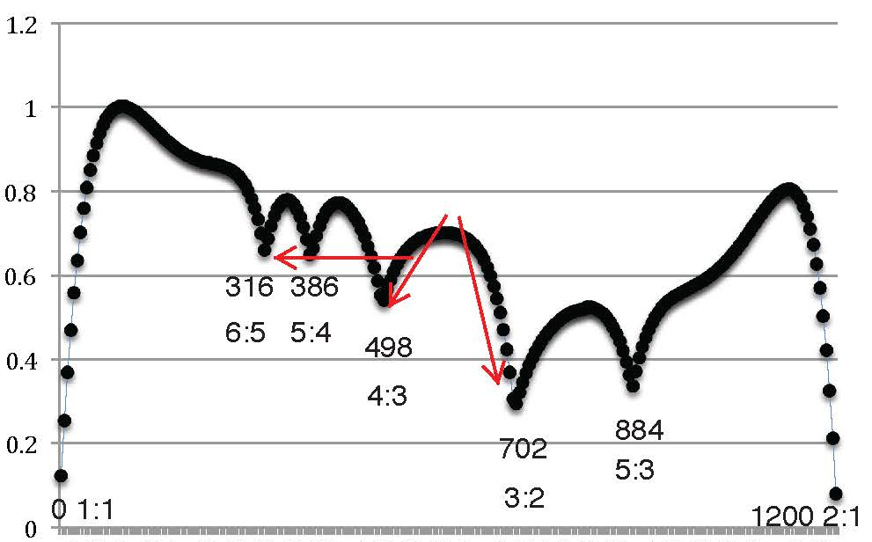

Figure 4. Roughness of the five intervals in the audio example.
Audacity freeware was employed to synthesize each partial of both tones as a 3-second sine tone.
Both tones comprise the first six partials, with amplitudes decreasing by 6 dB (decibels) per partial.
The total amplitude of each interval is faded from beginning to end (hence the decrease in roughness).
The lower tone of each interval is G4 = 392 Hz (cf. Figure 3, above).
The upper tones are, successively, 600, 575, 550, 525, and 500 cents above the lower tone.
Online software for SRA (Spectral and Roughness Analysis) was employed for the measurements (see Vassilakis 2007 and http://acousticslab.org/roughness/).
Note the substantial decrease in roughness at the fourth interval (525 cents) and—especially—at the fifth interval (500 cents).

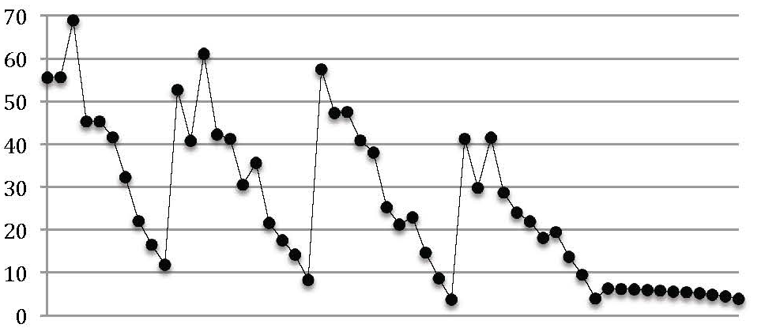

600 cents 575 cents 550 cents 525 cents 500 cents

Figure 5. Stepwise intervals and string numbers in nīd(i) qablim tuning.
Descending (a) and ascending (b) versions of nīd(i) qablim tuning.
In both versions, the la-zakû interval would comprise strings 4 and 7 (i.e., B and F, or F and B in the staff notation below).

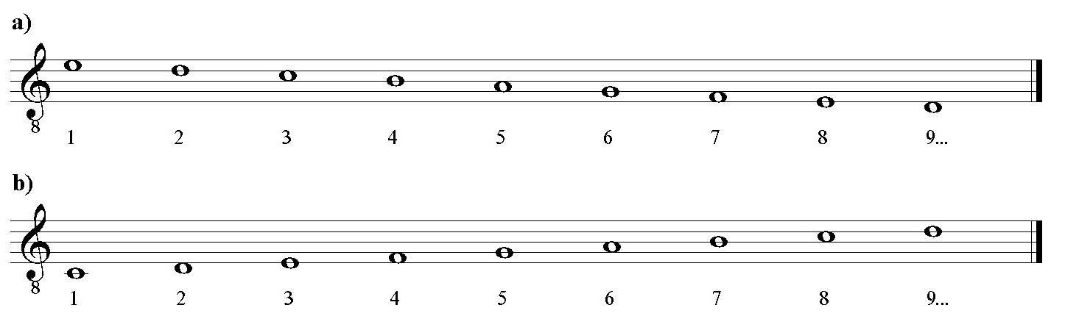

Figure 6. Transnotation of the only non-fragmentary piece of Mesopotamian music that has been excavated.
Descending version of nīd(i) qablim tuning is assumed (see Fig. 5, above).
Asterisks (*) indicate perfect-4th and perfect-5th dyads.
Oblique lines specify stepwise progressions from a tone in an imperfect interval (i.e., a 3rd or 6th) to a tone in a perfect 4th or perfect 5th.
To highlight contrary motion to a perfect prime, the prime is doubled at the octave.

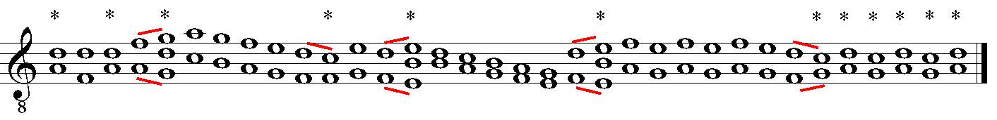

References Cited

Carey, Norman. 1998. Distribution modulo 1 and musical scales. Ph.D. dissertation, University of Rochester: https://www.academia.edu/3385414/Distribution_modulo_one_and_musical_scales

______ and David Clampitt. 1989. Aspects of Well-Formed Scales. Music Theory Spectrum 11: 187–206.
https://www.academia.edu/3385411/Aspects_of_well-formed_scales

Feder, Yitzakh. 2014. The Semantics of Purity in the Ancient Near East: Lexical Meaning as a Projection of Embodied Experience. Journal of Ancient Near Eastern Religions (JANER) 14: 87-113.
https://www.academia.edu/7420930/The_Semantics_of_Purity_in_the_Ancient_Near_East_Lexical_Meaning_as_a_Projection_of_Embodied_Experience

Mirelman, Sam. 2013. Tuning Procedures in Ancient Iraq. Analytical Approaches to World Music Journal (AAWM) 2/2: 43-56.
http://aawmjournal.com/articles/2013b/Mirelman_AAWM_Vol_2_2.html

Rahn, Jay. 2011a. The Hurrian Pieces, ca. 1350 BCE: Notation and Analysis. Analytical Approaches to World Music Journal (AAWM) 1/1: 93-151.
http://aawmjournal.com/articles/2011a/Rahn_AAWM_Vol_1_1.htm

______. 2011b. The Hurrian Pieces, ca. 1350 BCE: Part Two—From Numbered Strings to Tuned Strings.
Analytical Approaches to World Music Journal (AAWM) 1/2: 204-69.
http://aawmjournal.com/articles/2011b/Rahn_AAWM_Vol_1_2.pdf

______. 2015. Response to Mirelman: Orality and Aristoxenus; Pedagogy and Practice. Analytical Approaches to World Music Journal (AAWM) 4/1: in press—pre-publication page proofs at http://www.aawmjournal.com/articles/2014b/Rahn_AAWM_Vol_3_2.pdf

Vassilakis, Pantelis N. 2007. SRA: A Web-based Research Tool for Spectral and Roughness Analysis of Sound Signals. Proceedings SMC’07, 4th Sound and Music Computing Conference, Lefkada, Greece, 319-25.
http://musicalgorithms.ewu.edu/learnmoresra/files/vassilakis2007smc.pdf

Wulstan, David. 1968. “The Tuning of the Babylonian Harp.” Iraq 30/2: 215-38.

