Diradical Character as a Guiding Principle for the Insightful Design of Molecular Nanowires with an Increasing Conductance with Length
Thijs Stuyver,¹ Tao Zeng,² Yuta Tsuji,³ Paul Geerlings,¹ Frank De Proft¹

¹ Algemene Chemie, Vrije Universiteit Brussel, Pleinlaan 2, 1050 Brussels, Belgium

² Department of Chemistry, Carleton University, Ottawa, Ontario K1S5B6, Canada

³ Institute for Materials Chemistry and Engineering and IRCCS, Kyushu University, Nishi-ku, Fukuoka 819-0395, Japan

ABSTRACT

In recent years, a considerable interest has grown in the design of molecular nanowires with an increasing conductance with length. The development of such nanowires is highly desirable since they could play an important role in future molecular-scale circuitry. Whereas the first experimental observation of this non-classical behaviour still has to be realized, a growing number of candidate wires have been proposed theoretically. In this Letter, we point out that all the wires with an anti-Ohmic increasing conductance with length proposed so far share a common characteristic: their diradical character increases with length. The conceptual connection between diradical character and conductance enables a systematic design of such anti-Ohmic wires and explains the difficulty in their syntheses. A strategy is proposed to balance the stability and conductance, so that this non-classical phenomenon can be observed.
Conventional molecular nanowires act as tunnelling barriers. Their conductance G decays exponentially as their length L increases: $G=Ae^{-βL}$, where A is a prefactor and $β$ is the decay/attenuation factor. This decay corresponds to classical Ohmic behaviour. In recent years, a considerable interest has grown in the design of molecular nanowires with an increasing conductance with length, i.e. a negative$β$.,,,,,,,, ,, Such anti-Ohmic molecular wires are highly desirable since they could play an important role in future molecular-scale circuitry.¹¹ Whereas the first experimental observation of this non-classical behaviour still has to be realized, a growing number of candidate wires have been proposed theoretically. The so-called “reverse-exponential decay” of molecular conductance was first reported by Yoshizawa and Tada for nanographenes;² these results were later on corroborated by Li et al.⁴ Mandado and his co-workers described a similar reverse exponential decay of the conductance in quinoid wires.^{3,5} Later on, Tsuji and co-workers predicted that polyenes with reverse bond alternation patterns would also exhibit this non-classical behaviour.⁶ This realization has recently led to the proposal of cumulenes as interesting candidates for anti-Ohmic molecular wires (Fig. 1).¹² Around the same time, Algethami et al. presented a completely new porphyrin-based molecular nanowire which they predicted to also become (slightly) more conducting with an increasing length (Fig. 1).¹¹ This wire was considered especially promising since its Zn-coordinated analogue had been synthesized and is known to be sufficiently stable for its transport properties to be measured experimentally.

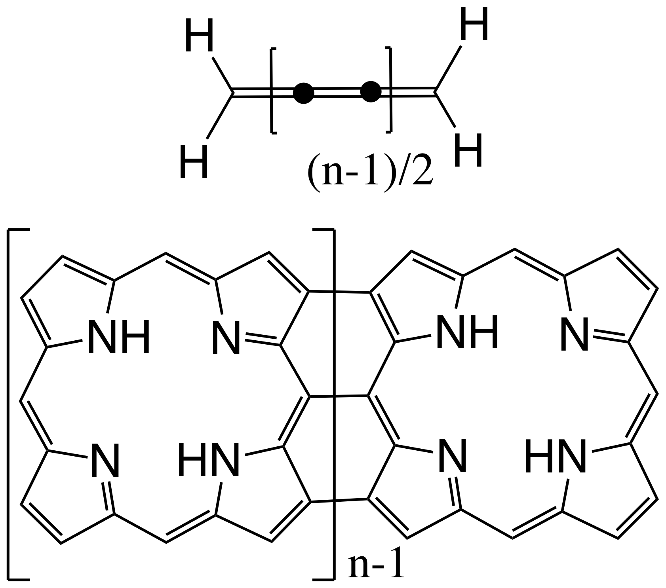
Figure 1. Cumulene[n], the promising candidate anti-ohmic wire recently proposed by Garner et al. (top) and fused porphyrin[n], the wire proposed by Algethami et al. (bottom).

In the present contribution, we point out the most important common feature of all these proposed wires, i.e., the ultimate driving force for their anti-Ohmic behavior: their diradical character increases with length. The conceptual connection between diradical character and molecular conductance enables a systematic design of anti-Ohmic wires. Furthermore, this connection immediately explains the common issue shared by the bulk of the proposed wires so far: that their longer analogues are very hard to handle/synthesize due to their inherent radical-like instability. We propose a systematic strategy to deal with this trade-off between the stability and the conductance. This approach can lead us to the experimental verification and exploitation of this non-classical behavior.
Let us first discuss the general factors that result in an increasing conductance with length. The most straightforward starting point for our argument is the expression of the zeroth order Green’s function in a tight-binding approach when contacts are connected to positions r and s of the conjugated system of a molecule:
 | $G_{rs}^{\left(0\right)R/A}\left(E\right)= \sum_{k}{\frac{C_{rk}C_{sk}^{*}}{E-ϵ_{k}±iη}}$ $,$ | (1)
where $C_{rk}$ is the kth molecular orbital’s (MO) expansion coefficient at site r, $ϵ_{k}$ is the MO energy, and $η$ is an infinitesimal positive number. Yoshizawa and co-workers demonstrated that, in a first approximation, the transmission probability around the Fermi level (and thus the conductance under small bias) through a molecule is proportional to the absolute square of this Green’s function evaluated at E = E_{F}, with E_{F} being the Fermi energy.¹⁴
In this expression of the zeroth order Green’s function, one can observe the basic features of a typical transmission spectrum (cf. Fig. 2): peaks in the transmission probability are present around the orbital energies (cf. the transport channels) and the intensity of the individual peaks is determined by the product of orbital coefficients on the contact sites.⁸
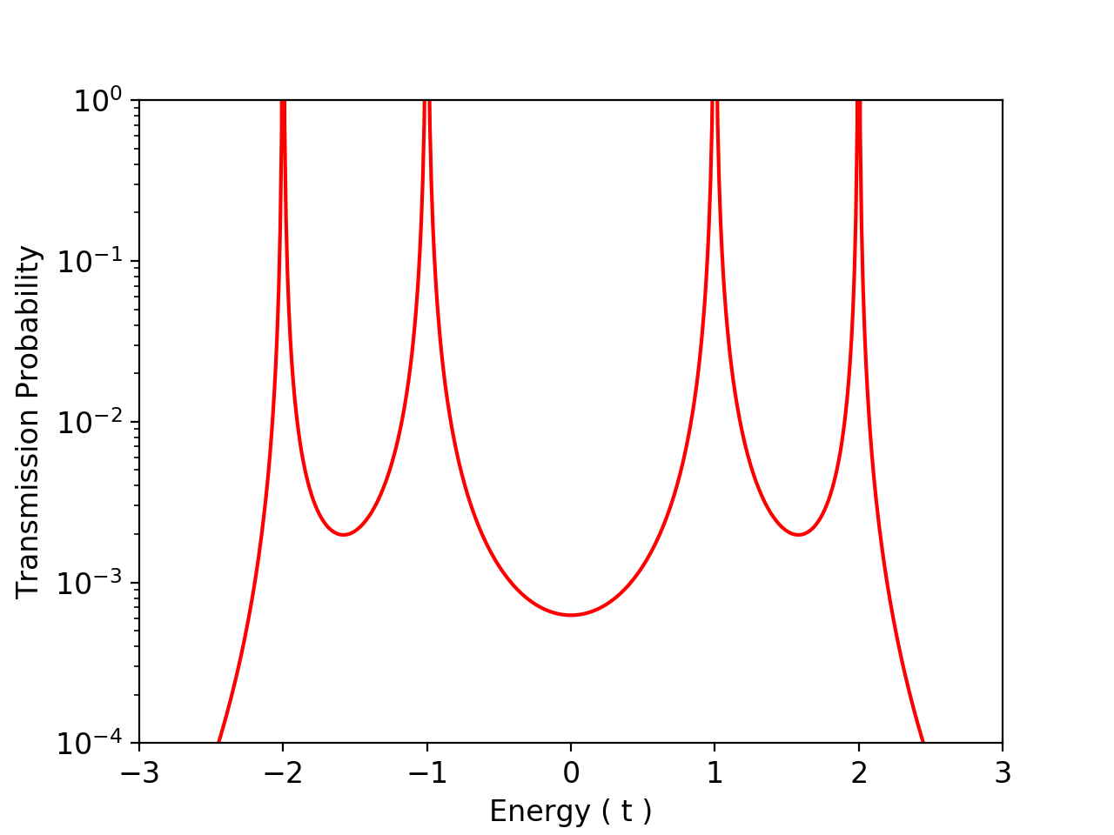
Figure 2. A sketch of the transmission spectrum for benzene connected in para-positions in the weak interaction limit, based on Eq. 11 in Ref. 8. t is the transfer integral between adjacent 2pπ orbitals in the benzene ring. We note that in calculations beyond the weak interaction approximation, the peaks in the transmission spectrum can be shifted significantly away from the orbital energies of the isolated molecule. On the x-axis, the Fermi level has been taken to be the zero energy for reference.

In general, when a molecule is connected into a circuit with the help of thiol-linkers, the Fermi level of the resulting junction will fall somewhere in the range between the peaks corresponding to the HOMO and LUMO. As such, around the Fermi energy, the contributions of the transport channels connected to the HOMO and LUMO will usually be the most important ones since the denominators in the corresponding terms in Eq. 1 will be the smallest:
 | $G_{rs}^{\left(0\right)R/A}\left(E_{F}\right)→ \frac{C_{rHOMO}C_{sHOMO}^{*}}{E_{F}-ϵ_{HOMO}}+\frac{C_{rLUMO}C_{sLUMO}^{*}}{E_{F}-ϵ_{LUMO}}$ $,$ | (2)
It is generally known that any conjugated system that is extended will lead to a decreasing HOMO-LUMO gap, which may converge to a finite value. As such, given Eq. 2, one can wonder the following: why are positive attenuation factors, i.e. a decreasing conductance with length, obtained for most conventional molecular wires? The only logical explanation is that the orbital coefficients on the contact sites usually fall off more quickly than that the HOMO and LUMO energies approach the Fermi level (the orbitals become more “spread out” as the size of the system increases).^{8,17} As such, anti-Ohmic behavior requires not only the HOMO-LUMO gap to become smaller as the length of the wire increases, but likewise importantly, the amplitudes of these orbitals on the two contact sites need to remain/become substantial. With these two conditions being satisfied, the zeroth order Green’s function at the Fermi energy increases in magnitude.
In our previous works,^{8,9} we – together with Roald Hoffmann and Stijn Fias – have considered different ways to increase the conductance of molecules and found it to be productive to link the transmission probability around the Fermi level to the concept of “diradical character”:,, an increasing weight of diradical resonance structures with the radical centers located on the contact positions in the resonance hybrid can be connected to a decreasing HOMO-LUMO gap and a localization of these orbitals on the desired positions and thus, according to Eq. 2, to an increasing conductance under small bias. Let us focus on the simple example in Fig. 3a. Since the depicted diradical resonance structure for benzene (upper right of the panel) can be expected to have a lower weight in its resonance hybrid than the depicted diradical resonance structure for p-quinodimethane (lower right), benzene will exhibit a lower conductance under small bias when contacts are connected in the corresponding positions, as depicted on the left-hand side of the figure by arrows.^{8,9}
`
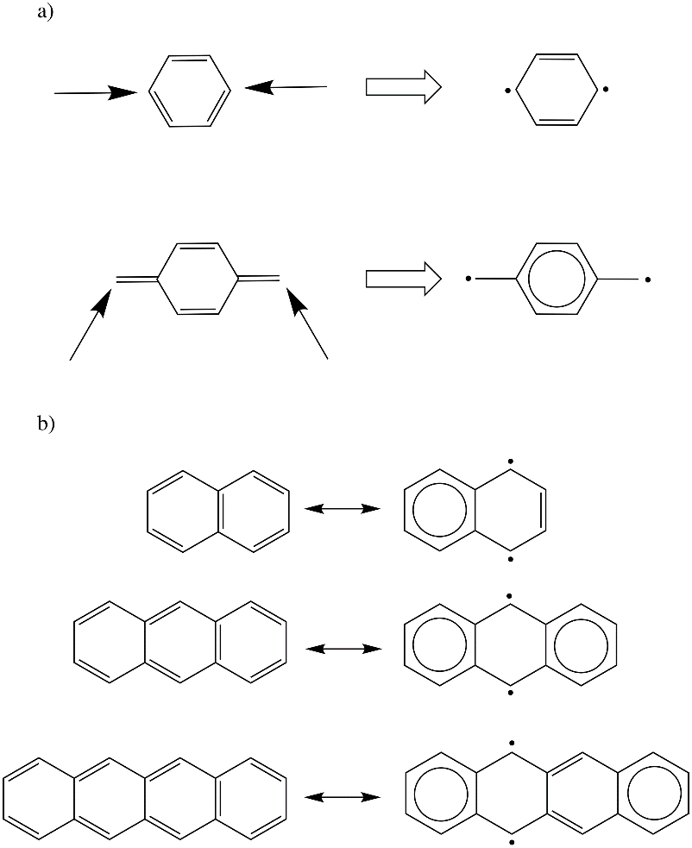
Figure 3. a) Consideration of the relative weight of specific diradical resonance structures in the resonance hybrid enables a qualitative estimation of the magnitude of the transmission probability when contacts are connected to the molecule through the positions corresponding to the radical centers in these structures. b) The main diradical resonance structures of naphthalene, anthracene and tetracene.
With such an understanding, we may employ established ideas to enhance diradical character of a wire as the number of repeating units increases, and hence the transmission probability around the Fermi level. In this way, we can design anti-Ohmic wires.⁹ But the prerequisite is that the repeating units have some diradical character by themselves. There should be some sort of a tipping point – a critical diradical character required in the repeating unit – which needs to be exceeded for the resulting wire to become anti-Ohmic.
Let us make this more concrete by focusing on a well-known group of compounds for which the diradical character can be tuned systematically: nanographenes. Simple resonance theory straightforwardly reveals that starting from naphthalene, the annealing of additional benzenoid rings to form anthracene, tetracene, etc. leads to an increasing weight of diradical resonance structures with the radical centers located on the central zigzag edges in the resonance hybrid (cf. Fig. 3b). This evolution is also reflected in the occupation number of the lowest unoccupied natural orbital (LUNO), n_{L}, an indicator of the diradical character of a compound, and the distributions of HONO (highest occupied NO) and LUNO.,,, In our calculations, n_{L} amounts to 0.12, 0.15, and 0.20 for naphthalene, anthracene, and tetracene. We constructed fused wires of these compounds, analogous to the fused-porphyrinoid wire proposed by Algethami et al.¹¹ We then connected the compounds to ethynylphenylthiol linkers and introduced the resultant complex into a circuit. The wires and their transmission spectra are shown in Fig. 4. From these spectra, it can be concluded that whereas the naphthalene-based wire exhibits the conventional decrease in conductance with length (the transmission probability at E = E_{F} decreases as subunits are added to the wire); the anthracene- and tetracene-based wires exhibit the desired increase in conductance with length. The increase of the conductance correlates with the steady decrease of the interconnecting bond lengths between the anthracene and tetracene units as the wire becomes longer (cf. table S1 in the Supporting Information). These shorter bonds suggest their more pronounced double-bond character, and hence the more pronounced radical characters at the two edges. Note that the naphthalene-based wire (poly-peri-naphthalene) has been amply described in the literature and is known to be stable., Bisanthene (n=2 in the anthracene-based wire in Fig. 4a, without the linkers) has been known to be stable enough to allow for regular spectroscopic measurements.,,,, Its stability can be enhanced by introducing bulky groups. As such, the anthracene-based wire can be regarded as a promising candidate for an experimentally verifiable molecular anti-Ohmic wire.
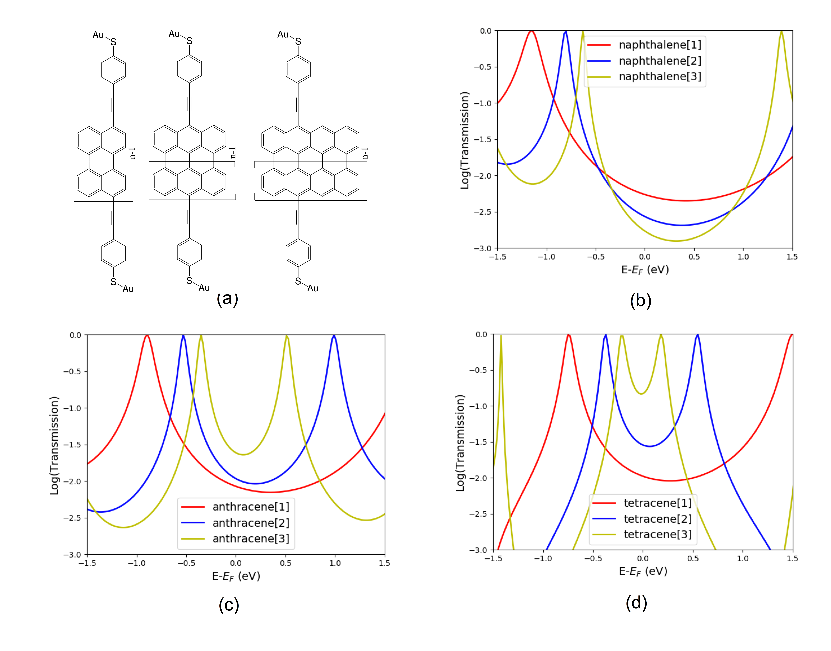
Figure 4. a) The fused naphthalene-, anthracene- and tetracene-based wires considered; transmission spectra for the three shortest analogues of b) the fused naphthalene-based wire, c) the fused anthracene-based wire, d) the fused tetracene-based wire.
Analysis of the transmission spectra in Fig. 4 leads to the conclusion that the tipping point in the diradical character, alluded to in the previous paragraph, ought to be located somewhere around n_{L} = [0.12, 0.15]. We note here that the numerical value of this tipping point should not be interpreted as an absolute/”hard” value: n_{L} values are dependent on the active space, correlation treatment and basis set employed. Nevertheless, in a first approximation, the values obtained for different compounds can be compared with one another to estimate the relative diradical character when a consistent methodology is used.
In Fig. 5, we compare the n_{L} values of the monomers of the different wires that have been proposed. In our recent study on the captodative effect,⁹ we started from an oligophenyl parental wire (n_{L} = 0.10 for its monomer: benzene), which exhibited an Ohmic behavior. When the diradical character is enhanced by captodative substitutions on the benzene monomer (e.g. diazadiborine, n_{L} = 0.15), the conductance started increasing with the length of the wire. All the substituted monomers that lead to wires which exhibited the anti-Ohmic behavior had n_{L} ≥ 0.15; the n_{L} value of anthracene. Butatriene, the starting point of the cumulene-based wire proposed by Garner et al., turns out to have an n_{L} of 0.16, also above the estimated tipping point.¹² For porphyrin, our calculations obtain an n_{L} of 0.13, which falls right in between the values for naphthalene and anthracene and should thus be in the border area. The transport calculations performed by Algethami et al. on porphyrin-based wires pointed to an extremely mild (and Fermi level dependent) increase in conductance. Our own calculations indicate a slight decrease in conductance with length (cf. Fig. S3 in the Supporting Information). Furthermore, the Zn-coordinated analogue of porphyrin turns out to exhibit a reduced diradical character compared to the uncoordinated porphyrin, with a smaller 0.10 n_{L}. This is the exact same value as was obtained for benzene and just like the oligophenyl wire, the available experimental data point to an Ohmic conductance for this fused Zn-complexed porphyrinoid wire.¹³ In Fig. 5, a graphical overview of the order of the diradical character of the aforementioned monomers is given, along with the approximate order of the conductance evolution with length.

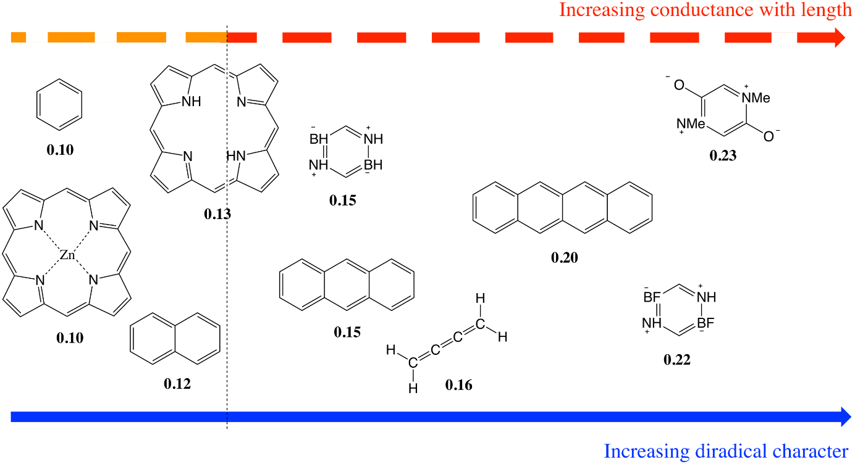
Figure 5. The monomers of the proposed wires so far ranked according to their diradical character (n_{L} values in bold). The attenuation factors – which have been extracted from the literature and/or (re)calculated computationally – follow approximately the same trend: for the compounds with little diradical character (benzene, naphthalene), the conductance decreases with length, for the compounds with high diradical character, the conductance increases with length. The approximate location of the tipping point is denoted by a vertical dashed line. Porphyrin is situated right around the tipping point.

It should be stressed here that the diradical character of the monomer is of course not the only determinant of the $β$ factor of a molecular wire. A significant covalent interaction between the adjacent repeating units is needed so that the main resonance structure of the resultant wire has only two effectively unpaired electrons left at the two termini and the diradical character of the wire as a whole increases with length (see section S3 of the Supporting Information for an illustration of this effect). A logical consequence is that steric hindrance, which prevents the inter-chromophore covalent coupling, certainly disfavors the anti-Ohmic behavior.⁹ This is also the main reason why the fusion of the individual repeating units favors the anti-Ohmic behavior in the porphyrin-, anthracene-, and tetracene-based wires previously discussed. As an illustration, we included the transmission spectra for a non-fused analogue of anthracene, exhibiting conventional Ohmic behavior ($β$ = 1.81 nm⁻¹), in the Supporting Information (cf. Fig. S4). Additionally, the choice of the linker units can also influence the magnitude of the $β$ factor: if short and/or well-conjugated linkers (e.g., ethynylthiol) are used, then the conductance will be quite elevated already for the monomer, so that there is only a small room for growth as the length of the wire increases; longer and/or less-conjugated linkers (e.g., ethynylphenylthiol) lead to a relatively lower conductance for the monomer so that there is a larger room for growth. A more in-depth discussion of these phenomena combined with correlations between n_{L} and the $β$ factors for the different wires can be found in the Supporting Information (cf. section S4). Nevertheless, our analysis clearly demonstrates that sufficient diradical character of repeating unit is a necessary condition for an increasing conductance with length.
Furthermore, the results presented here indicate that there is a trade-off between the stability and anti-Ohmic behaviour of the wires. Wires based on compounds with low diradical character (benzene, naphthalene, Zn-coordinated porphyrin) are generally known to be stable and have been synthesized, whereas the stability and synthesizability of most of the proposed wires based on monomers with high diradical character (tetracene, the captodatively substituted benzene derivatives and cumulene) are yet to be confirmed. The calculated drop off in the diradical character upon introducing Zn-ions inside the porphyrin moieties demonstrates that attempts to stabilize wires may modify the fundamental electronic structure of the repeating unit and eliminate the anti-Ohmic character, a natural result of stabilization through reduction of diradical character.
This brings us to the final issue raised in the introduction of this letter: how can we balance stability and the increased conductance with length and design stable anti-Ohmic wires that can be measured experimentally?
We are convinced that, given the existence of many computationally inexpensive indices to quantify diradical character, a systematic optimization of this property towards the approximate tipping-point previously discussed, would be the most effective strategy. In practice, one could start from a compound with considerable diradical character, but slightly below the tipping point (e.g. naphthalene or, more generally, a compound obtained through a high-throughput screening of compound databases), and systematically probe the effect of a wide range of structural modifications on the diradical character, so that a variety of analogues can be selected which attain or slightly exceed the critical diradical character. Along the way, one could also probe the effect of different stabilization strategies (e.g. steric hindrance etc.) on the diradical character of a compound, in the hope of finding stabilization methods that do not affect the anti-Ohmic behavior of the resulting wire (in contrast to the Zn-complexation strategy of porphyrin used by Sedghi et al. in Ref. 13). Here, a lot of inspiration could come from previous work on the stabilization of monoradicals.,, Please note that the search for candidate repeating units for anti-Ohmic wires can be combined with the seeking for singlet fission chromophores, which are also characterized as diradicaloids.,,,,,,, The two vibrant research fields of molecular conductors and organic photovoltaics are hence cross-linked by the common theme of diradical character. Interaction with experimentalists should then lead to a selection of realistic and synthesizable compounds which could subsequently be tested in the lab. We believe that such a systematic strategy – instead of the current trial and error approach – will facilitate the experimental verification and exploitation of this anti-Ohmic behavior of nanowires.

Acknowledgements

T.S. acknowledges the Research Foundation-Flanders (FWO) for a position as research assistant (11ZG615N). T.Z. thanks Carleton University of the start-up grant (186853) and the Natural Sciences and Engineering Research Council (NSERC) of Canada for funding (RGPIN-2016-06276). Y.T. thanks Research Institute for Information Technology (Kyushu University) for the computer facilities and financial support from JSPS KAKENHI Grant Number JP17K14440 and JP18H04488. P.G. and F.D.P. wish to acknowledge the Vrije Universiteit Brussel (VUB) for a Strategic Research Program. F.D.P. also acknowledges the Francqui foundation for a position as Francqui research professor. Computational resources and services were provided by the Shared ICT Services Centre funded by the Vrije Universiteit Brussel, the Flemish Supercomputer Center (VSC) and FWO, as well as Compute Canada.

Supporting Information

See Supporting Information for the transmission spectra for the cumulene-, fused porphyrin- and non-fused anthracene-based wires, the evolution of the interconnecting bond lengths between the subunits in the fused naphthalene-, anthracene- and tetracene-based wires, an illustration of the importance of a significant covalent interaction between the repeating units and the correlation between the diradical character and the evolution of the conductance.

Computational Methods

The electron transport calculations were performed using the Non-Equilibrium Green’s Function (NEGF) method combined with DFT as implemented in the Artaios code,, a post-processing tool for, among others, Gaussian 09. The electrode geometry used in the transmission calculations consists of nine gold atoms per electrode, which are arranged as a six-atom triangular fcc-gold (111)-surface, with a second layer consisting of three gold atoms. The distance between gold atoms in the clusters was set to 2.88 Å. Ethynylphenylthiol linkers were attached to the wires to facilitate the connection to the contacts. From the optimized molecular structures, the thiol’s hydrogen atoms were removed and the Au₉ clusters were attached in accordance with the methodology presented in a recent study. The adsorption site is the middle fcc-hollow site of the first layer. The Au-S distance was set to 2.48 Å. For the resulting structures, single-point calculations were performed at the B3LYP/LanL2DZ level of theory, again using the Gaussian 09 software. In the final step, the Hamiltonian and overlap matrices were extracted to carry out the NEGF calculation within the wide-band-limit (WBL) approximation. In the WBL approximation, we set the local density of states (LDOS) of the electrode surface to a constant value of 0.036 eV⁻¹. This value was taken from the literature.⁵⁴ To estimate the diradical character, structures of the different compounds were optimized at the B3LYP/cc-pVDZ level of theory. Complete-active-space self-consistent-field (CASSCF) calculations with the same basis set were carried out for those structures to obtain n_{L} of the ground state wave functions. The active spaces include all $π$ orbitals for cumulene, butatriene, naphthalene, and anthracene, 14 $π$ orbitals and 14 electrons for tetracene (14$π$14e, which gives the same result as 16$π$16e), and 12$π$12e for porphyrin and its Zn complex. The monomer calculations were carried out using GAMESS-US.,

To whom correspondence should be addressed. E-mail: Thijs.Stuyver@vub.be
Datta, S. Electronic transport in mesoscopic systems, 1995, Cambridge University Press, Cambridge.
Tada, T.; Yoshizawa, K. J. Phys. Chem. B 2004, 108 (23), 7565-7572.
Ramos-Berdullas, N.; Mandado, M. Chem. Eur. J. 2013, 19 (11), 3646-3654.
Li, S.; Gan, C. K.; Son, Y.-W.; Feng, Y. P.; Quek, S. Y. Carbon 2014, 76, 285-291.
Ramos-Berdullas, N; Ferro-Costas, D.; Mandado, M. Comput. Theor. Chem. 2015, 1053, 263-269.
Tsuji, Y.; Movassagh, R.; Datta, S.; Hoffmann, R. ACS Nano 2015, 9 (11), 11109-11120.
Stuyver, T.; Fias, S.; De Proft, F.; Geerlings, P. Chem. Phys. Lett. 2015, 630, 51-56.
Stuyver, T.; Fias, S.; De Proft, F.; Geerlings, P.; Tsuji, Y.; Hoffmann, R. J. Chem. Phys. 2017, 146 (9), 092310.
Stuyver, T.; Zeng, T.; Tsuji, Y.; Fias, S.; Geerlings, P.; De Proft, F. J. Phys. Chem. C 2017, 122 (6), 3194-3200.
Ramos-Berdullas, N.; Gil-Guerrero, S.; Mandado, M. Int. J. Quant. Chem. 2018, e25651.
Algethami, N.; Sadeghi, H.; Sangtarash, S.; Lambert, C. J. Nano Lett. 2018, 18, 4482-4486.
Garner, M. H.; Bro-Jorgensen, W.; Pedersen, P. D.; Solomon, G. C. J. Phys. Chem. C 2018, DOI: 10.1021/acs.jpcc.8b05661
Sedghi, G.; Esdaile, L. J.; Anderson, H. L.; Martin, S.; Bethell, D.; Higgins, S. J.; Nichols, R. J. Adv. Mater. 2012, 24, 653-657.
Yoshizawa, K.; Tada, T.; Staykov, A. J. Am. Chem. Soc. 2008, 130, 9406-9413.
Xue, Y.; Datta, S.; Ratner, M. A. J. Chem. Phys. 2001, 115, 4292– 4299
Tsuji, Y.; Hoffmann, R. Angew. Chem., Int. Ed. 2014, 53, 4093-4097.
Tada, T.; Yoshizawa, K. Phys. Chem. Chem. Phys. 2015, 17, 32099-32110.
Perepichka, D. F.; Bryce, M. R. Angew. Chem., Int. Ed. 2005, 44, 5370-5373.
Giacalone, F.; Segura, J. L.; Martin, N.; Guldi, D. M. J. Am. Chem. Soc. 2004, 126, 5340-5341.
Kamada, K.; Ohta, K.; Shimizu, A.; Kubo, T.; Kishi, R.; Takahashi, H.; Botek, E.; Champagne, B.; Nakano, M. J. Phys. Chem. Lett. 2010, 1, 937-940.
Minami, T.; Nakano, M. Phys. Chem. Lett. 2011, 3, 145-150.
Voigt, B. A.; Steenbock, T.; Herrmann, C. arXiv preprint arXiv:1802.06695.
Solà, M. Front. Chem. 2013, 1, 22.
Doehnert, D.; Koutecky, J. J. Am. Chem. Soc. 1980, 102, 1789-1796.
Minami, T.; Ito, S.; Nakano, M. J. Phys. Chem. Lett. 2012, 3, 2719-2723.
Minami, T.; Ito, S.; Nakano, M. J. Phys. Chem. Lett. 2013, 4, 2133-2137.
Hachmann, J.; Dorando, J. J.; Avilés, M.; Chan, G. K. L. J. Chem. Phys. 2007, 127, 134309.
Murakami, M.; Yohimura, S. J. Chem. Soc. Chem. Commun. 1984, 24, 1649-1650.
Iqbal, Z.; Ivory, D. M.; Marti, J.; Brédas, J. L.; Baughman, R. H. Mol. Cryst. Liq. Cryst. 1985, 118, 103-109.
Brockmann, H.; Randebrock, R. Chem. Ber. 1951, 84, 533-545.
Kuroda, H. J. Chem. Phys. 1960, 33, 1586-1587.
Clar, E.; Schmidt, W. Tetrahedron 1977, 33, 2093-2097.
Arabei, S. M.; Pavich, T. A. J. Appl. Spectrosc. 2000, 67, 236-244.
D’yachenko, G. G.; Petukhoc, V. A.; Arabei, S. M.; Pavich, T. A. J. Appl. Spectrosc. 2003, 70, 208-2015.
Hirao, Y.; Konishi, A.; Matsumoto, K.; Kurata, H.; Kubo, T. AIP Conf. Proc. 2012, 863, 863-866.
Cutarolo, S.; Hart, G. L.; Nardelli, M. B.; Mingo, N.; Sanvito, S.; Levy, O. Nature Mater. 2013, 12, 191-201.
Grimme, S.; Schreiner, P. R. Angew. Chem., Int. Ed. 2011, 50, 12639-12642.
De Vleeschouwer, F.; Chankisjijev, A.; Yang, W.; Geerlings, P.; De Proft, F. J. Org. Chem. 2013, 78, 3151-3158.
De Vleeschouwer, F.; Chankisjijev, A.; Geerlings, P.; De Proft, F. Eur. J. Org. Chem. 2015, 3, 506-513.
Tidwel, T. T. Tetrahedron 1978, 34, 1855-1868.
Akdag, A.; Havlas, Z.; Michl, J. J. Am. Chem. Soc. 2012, 134, 14624-14631.
Minami, T.; Nakano, M. J. Phys. Chem. Lett. 2012, 3, 145-150.
Zeng, T.; Ananth, N.; Hoffmann, R. J. Am. Chem. Soc. 2014, 136, 12638-12647.
Wen, J.; Havlas, Z.; Michl, J. J. Am. Chem. Soc. 2015, 137, 165-172.
Zeng, T.; Goel, P. J. Phys. Chem. Lett. 2016, 7, 1351-1358.
Zeng, T. J. Phys. Chem. Lett. 2016, 7, 4405-4412.
Zeng, T.; Mellerup, S. K.; Yang, D.; Wang, X.; Wang, S.; Stamplecoskie, K. J. Phys. Chem. Lett. 2018, 9, 2919-2927.
Japahuge, A.; Zeng, T. ChemPlusChem 2018, 83, 146-182.
C. Herrmann, G. C. Solomon, J. E. Subotnik, V. Mujica, M. A. Ratner, J. Chem. Phys. 2010, 132, 024103.
Deffner, M.; Groß, L.; Steenbock, T.; Voigt, B. A.; Solomon, G. C.; Herrmann, C. Artaios — a Code for Postprocessing Quantum Chemical Electronic Structure Calculations, available from https://www.chemie.uni-hamburg.de/ac/herrmann/software/index.html (2008-2017).
Frisch, M. J.; Trucks, G. W.; Schlegel, H. B.; Scuseria, G. E.; Robb, M. A.; Cheeseman, J. R.; Scalmani, G.; Barone, V.; Mennucci, B.; Petersson, G. A.; et al. Gaussian 09, Revision D.01, Gaussian, Inc., Wallingford CT, 2009.
Schlicke, H.; Herrmann, C. ChemPhysChem 2014, 15, 4011-4018.
Bilić, A.; Reimers, J. R.; Hush, N. S. J. Chem. Phys. 2005, 122, 094708.
Herrmann, C.; Solomon, G. C.; Ratner, M. A. Designing Organic Spin Filters in the Coherent Tunneling Regime. J. Chem. Phys. 2011, 134, 224306.
Schmidt, M. W.; Baldridge, K. K.; Boatz, J. A.; Elbert, S. T.; Gordon, M. S.; Jensen, J. H.; Koseki, S.; Matsunaga, N.; Nguyen, K. A.; Su, S.; Windus, T. L.; Dupuis, M.; Montgomery, J. A., Jr. J. Comput. Chem. 1993, 14, 1347-1363.
Gordon, M. S.; Schmidt, M. W., Advances in Electronic Structure Theory: GAMESS a Decade Later in Theory and Applications of Computational Chemistry: The First Forty Years, Dykstra, C. E.; Frenking, G.; Kim, K. S.; Scuseria, G. E. (Eds) 2005, Elsevier, Amsterdam Chap. 41, pp 11167-1189.

