Five Stages of Roughness between 600 and 500 cents

Jay Rahn, April 10, 2015

Click on the following link for the audio file that accompanies this :
http://yorkspace.library.yorku.ca/xmlui/handle/10315/28543

Audacity freeware was employed to synthesize each partial of both tones as a 3-second sine tone.
Both tones comprise the first six partials, with amplitudes decreasing by 6 dB (decibels) per partial.
The total amplitude of each interval is faded from beginning to end (hence the decrease in roughness within each interval).
The lower tone of each interval is G3 = 196 Hz.
The upper tones are, successively, 600, 575, 550, 525, and 500 cents above the lower tone.
Online software for SRA (Spectral and Roughness Analysis) was employed for the measurements below: see Vassilakis 2007 and http://acousticslab.org/roughness/.
Note the substantial decrease in roughness at the fourth interval (525 cents) and—especially—at the fifth interval (500 cents).

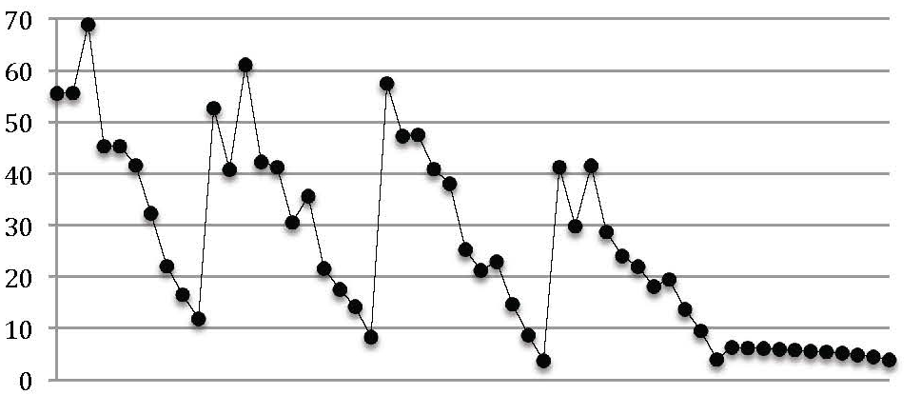

600 cents 575 cents 550 cents 525 cents 500 cents

Reference:
Vassilakis, Pantelis N. 2007. SRA: A Web-based Research Tool for Spectral and Roughness Analysis of Sound Signals. Proceedings SMC’07, 4th Sound and Music Computing Conference, Lefkada, Greece, 319-25. http://musicalgorithms.ewu.edu/learnmoresra/files/vassilakis2007smc.pdf

