Digital Takeaway for TESS Presentation - Inside Out: A Curriculum for Making Grant Outputs into OER

Linked Table of Contents:
Slides & Speaking Notes from Presentation
Getting Started Content Block on Moodle
Module 1: OER 101
Module 2: Copyright & Open Licensing
Module 3: Finding & Evaluating OER
Module 4: Depositing into YorkSpace

Slides & Speaking Notes from Presentation
- Access a view only copy of our TESS slides (includes speaking notes in the Notes Section)

Getting Started Content Block on Moodle
Open Education Training Program for AIF recipients
Welcome to YorkU Libraries’ inaugural Open Education Training Program for Academic Innovation Fund (AIF) recipients! We are delighted that you can join us. This training will support you in fulfilling the open educational resource (OER) component of your AIF contract with the university.
How does this program work?
We will use Moodle to organize the program. There are a total of 4 modules in the program:
  - OER: 101
  - Copyright & Open Licensing
  - Finding & Evaluating OER
  - Depositing to YorkSpace

Time Commitment & Program Structure:
Each module will take one week to complete. There are 4 components to each module:
1. Warm-Up (Recommended): Each module includes a short warm-up activity, such as a video clip and a short survey. Warm-up activities will take no more than 10 minutes to complete. We encourage you to complete each warm-up activity prior to viewing the pre-recorded lecture, so you can fully engage in the activities embedded in the lecture.
2. Pre-Recorded Lecture (Required): The pre-recorded lectures (approximately 40 minutes of content) have been developed by the program's facilitators and will introduce all participants to the module content. There will be interactive questions and activities embedded in the pre-recorded lectures to help you test your understanding of the material. The slides will also be made available as a PDF document.
3. Building Block Activity (Recommended): Each module will have a building block assignment which is designed to help you apply your new knowledge and create deliverables that feed directly into the project planning and development of your AIF project. The time commitment for these activities will vary, but will typically take 20-30 minutes to complete.
4. Additional Resources: For those who would like to delve deeper into the module content, we have included a set of additional readings and videos for each module. These are not mandatory.
Moodle Forums Used in this Program:
  - Course Announcements Forum: Program announcements will be posted in this forum.
  - Building Block Activity Forums: Participants are encouraged to post their completed Building Block activities for each module to their respective building block forums. While these forums will be monitored by the facilitators, we encourage participants to also provide peer feedback.
  - Discussion Forum: Participants are encouraged to post questions, thoughts, ideas, progress updates, and any challenges they encounter on this forum. The forum will be monitored by the instructors, but we also encourage participants to respond to each other and provide peer feedback.

Important! Moodle is meant to be a safe, private space where you and your fellow module participants can interact. Please treat the information you read there sensitively.
Program Facilitators:
  - Stephanie Quail, Teaching and Learning Librarian, quailste@yorku.ca
  - Sarah Coysh, Digital Engagement Librarian, scoysh@yorku.ca

Module 1: OER 101

H5P Pre-recorded Lecture Materials
- H5P for Module 1: OER 101
- Transcript for Videos in Module 1: OER 101
- View-only version of Google Slide deck for Module 1: OER 101

Warm-Up Activity (Recommended)
Please watch this video and complete the following questionnaire before viewing the pre-recorded lecture for Module 1. This task is recommended, but not required and will take no more than 10 minutes to complete.

Video Attribution: Mireles, N. (2012, June 5). Open education matters: Why is it important to share content? [Video file]. YouTube. https://www.youtube.com/watch?v=dTNnxPcY49Q / Available under Creative Commons Attribution license

Questionnaire for Module 1: OER 101
Your answers to this brief questionnaire will only be viewed by the program facilitators.

Questionnaire:

- How would you describe your knowledge of Open Educational Resources?

- Excellent | Very Good | Good | Poor

- How often do you use Open Educational Resources in your own teaching?

- Excellent | Very Good | Good | Poor

- Please list any questions about Open Educational Resources that you are hoping will be answered in these modules.

Pre-recorded Lecture (Required)
After you complete the pre-recorded lecture content, you will be able to:

- Define the key characteristics of open educational resources (OER).
- List and describe examples of OER.
- Identify key benefits OER provide to faculty and students.

Access Instructions for Pre-Recorded Lecture Materials:

Step 1: Go to the Module 1 pre-recorded lecture on eCampusOntario's H5P Studio

Step 2: Click the double arrow button in the bottom-right corner to watch the module in full-screen mode.

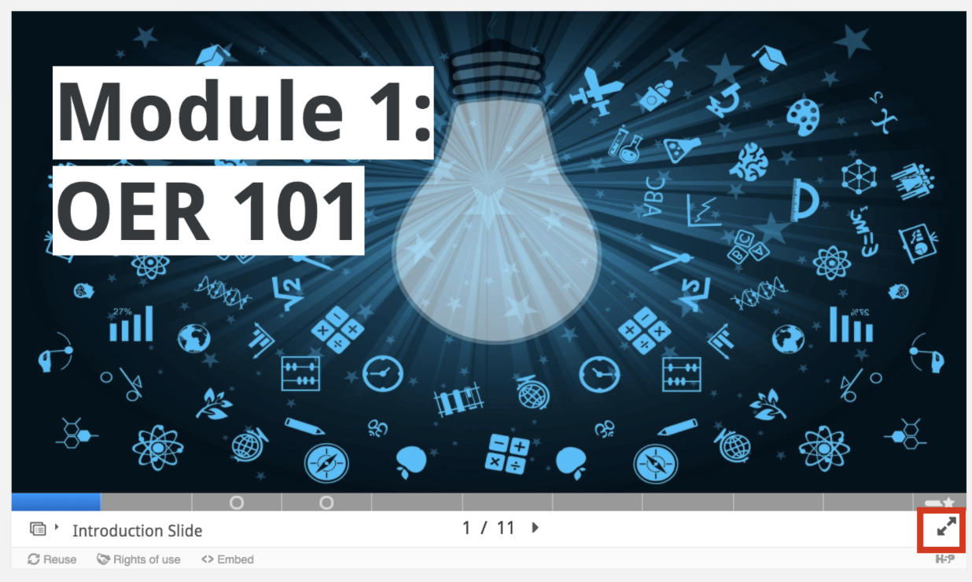

Step 3: When you complete the module, click Export Text to download a copy of the content you entered into the Module's text boxes.

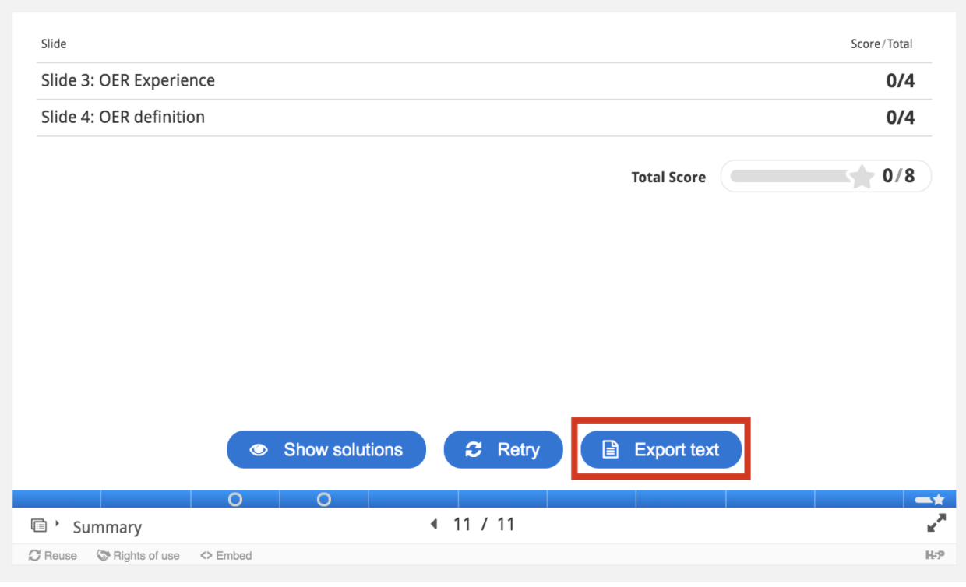

- Transcripts to videos in Module 1’s Pre-Recorded Lecture

Building Block Activity (Recommended)
Open in order to...what?

Introduction:

The Scholarly Publishing and Academic Resources Coalition (SPARC) provides the prompt “open in order to” to focus on the why of open, and not just the how. This reflection helps open practitioners make thoughtful, deliberate choices when designing learning materials. You can browse responses to this prompt at the website, Open In Order To.

Instructions:

This activity is recommended, but not required. It will take approximately 10-20 minutes to complete. Please answer the following questions. Writing in point form or sentence form is appropriate.

- Describe which components of your AIF project will benefit York faculty and students the most. Why will they have the most benefit to them?
- Will any of these components be made into an OER? If yes, how might they benefit students, faculty, and community members outside of York?

Optional:

Please consider posting your ideas to the Module 1: Building Block Activity Forum and also commenting on other participants’ answers.

Due Date:

July 20, 2020

Additional Resources
Defining OER:
- Bliss, T. J. & Smith, M. (2017). A brief history of open educational resources. In R.S. Jhangiani & R. Biswas-Diener (Eds.), Open: The philosophy and practices that are revolutionizing education and science (pp. 9–27). Ubiquity Press. https://doi.org/10.5334/bbc.b
- SPARC. (2017, October 25). OER mythbusting. https://sparcopen.org/wp-content/uploads/2017/10/OER_Mythbusting_2017.pdf
Benefits of OER:
- Jhangiani, R. S., Dastur, F. N., Le Grand, R., & Penner, K. (2018). As good or better than commercial textbooks: Students’ perceptions and outcomes from using open digital and open print textbooks. The Canadian Journal for the Scholarship of Teaching and Learning, 9(1). https://doi.org/10.5206/cjsotl-rcacea.2018.1.5
- DeRosa, R. (2017, November 1). OER: Bigger than affordability. Inside Higher Education. https://www.insidehighered.com/digital-learning/views/2017/11/01/oer-catalyst-national-conversation-about-public-higher-education#.WhRt03-s_bh.link
- Hilton, J. (2016). Open educational resources and college textbook choices: A review of research on efficacy and perceptions. Educational Technology Research and Development, 64, 573-590. https://doi.org/10.1007/s11423-016-9434-9
  - Video Summary of Paper: Research Shorts. (2016, December 2). A review of the effectiveness & perceptions of open educational resources as compared to textbooks [Video file]. YouTube. https://www.youtube.com/watch?v=SX0K0hb_xKE / Available under a Creative Commons Attribution license
Considerations Before Using or Creating an OER:
- McNally, M.B. & Christiansen, E.G. (2019). Open enough? Eight factors to consider when transitioning from closed to open resources and courses: A conceptual framework. First Monday, 24(6). http://dx.doi.org/10.5210/fm.v24i6.9180

Module 2: Copyright & Open Licensing

H5P Pre-recorded Lecture Materials
- H5P for Module 2: Copyright and Open Licensing
  - Available under a Creative Commons Attribution-NonCommercial-ShareAlike 4.0 international licence
- Transcript for Videos in Module 2: Copyright and Open Licensing
- Transcript for University of Guelph Libraries video used in Module 2
  - Available under a Creative Commons Attribution-NonCommercial-ShareAlike 4.0 international licence
- View-only version of Google Slide deck for Module 2: Copyright and Open Licensing

Warm-Up Activity (Recommended)
Please read the FAQ - Online Course Materials and Copyright (PDF) and complete the following questionnaire before viewing the pre-recorded lecture for Module 2. This task is recommended, but not required and will take no more than 10 minutes to complete.

Questionnaire for Module 2: Copyright and Open Licensing
Your answers to this brief questionnaire will only be viewed by the program facilitators.

Questionnaire:

- How would you describe your knowledge of open licences, such as Creative Commons licences?

- Excellent | Very Good | Good | Poor

- Have you ever licensed any of your educational materials with a Creative Commons licence?

- Yes | No

- List any questions you have about open licensing that you hope will be answered in Module 2.

Pre-recorded Lecture (Required)
After you complete the pre-recorded lecture content, you will be able to:
- Define key Canadian copyright protections as they relate to creators of academic and/or creative works.
- Describe how Creative Commons licences provide a standardized approach for granting more permissive copyright permissions for academic and creative works.
- Explain how Creative Commons licences facilitate the creation of OER and describe the permissions provided by the most commonly used Creative Commons licences (i.e. CC BY, CC BY-NC)
- Create a well-structured Creative Commons licence statement for the open component of your AIF project.
Access Instructions for Pre-Recorded Lecture Materials:
Step 1: Go to the Module 2 pre-recorded lecture content on eCampusOntario's H5P site.

Step 2: Click the double arrow button in the bottom-right corner to watch the module in full-screen mode.
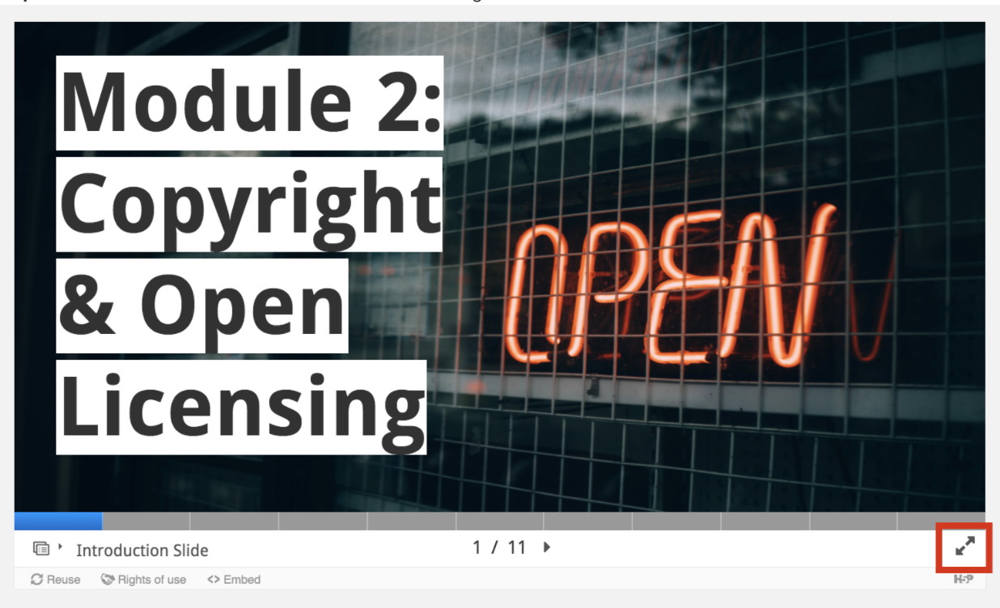

Step 3: When you complete the module, click Export Text to download a copy of the content you entered into the Module's text boxes.

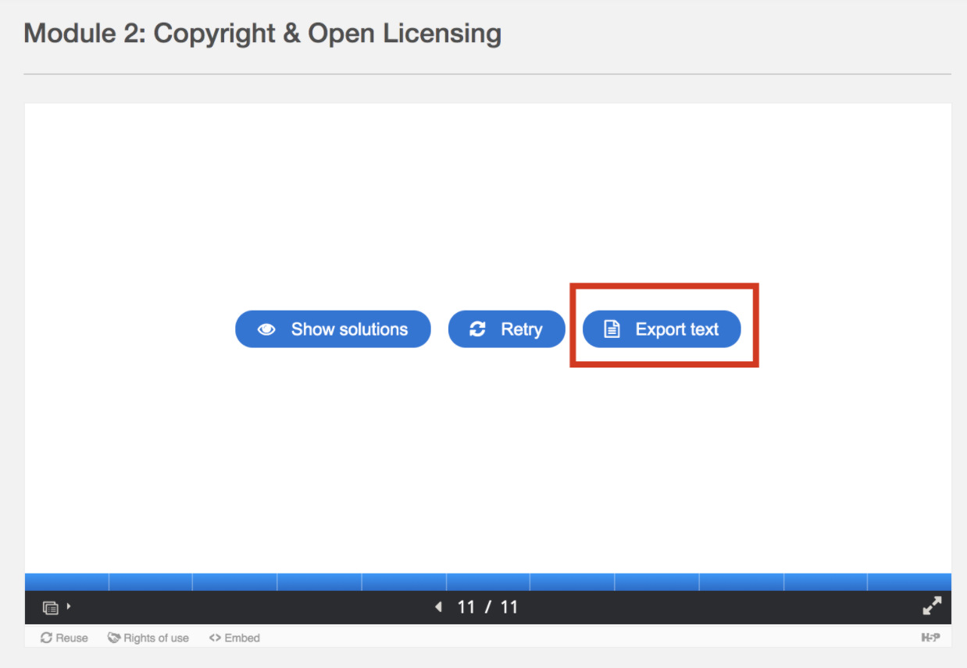

- Transcript for pre-recorded lecture videos in Module 2

Building Block Activity (Recommended)
Introduction:

In the pre-recorded lecture for Module 2 we discussed Creative Commons licences and how they can be used to create OER. This building block activity (approximately 15 minutes) will help you learn more about incorporating other OER into your own project and combining content that uses different Creative Commons licences.

Instructions:

Watch Part 2 of this video from the Orange Grove Repository on combining OER licences (5 minutes).

Video Attribution: The Orange Grove Repository. (2012, September 5). Creating OER and combining licenses - Full [Video file]. YouTube. https://youtu.be/Hkz4q2yuQU8 / Available under a Creative Commons Attribution-ShareAlike 3.0 Unported licence

Answer the following questions (10 minutes):

- Which Creative Commons licence do you plan on using for the open component of your AIF project? Why does this licence appeal to you?

- Based on the above video, what are some challenges you may experience when using other OER in your AIF project (i.e. openly licensed images, photos, exercises)?

Optional:

Please consider posting your answers to the below Forum and also commenting on other participants’ answers.

Due Date:

July 27, 2020

Additional Resources
Canadian Copyright Resources:
York University. (2020). Copyright @ York. https://copyright.info.yorku.ca
- This website was prepared by York's Copyright Office and provides official university guidance on copyright related questions.
University of Alberta. (2020). Opening up copyright instructional modules. https://sites.library.ualberta.ca/copyright/
- Includes video modules on fair dealing, history of Canadian copyright, open licensing and Creative Commons
The Learning Portal. (2020). Copyright literacy for Ontario college employees. https://tlp-lpa.ca/faculty-toolkit/copyright
- Includes seven short modules on Canadian copyright basics, as well as links to fair dealing assessment tools.
Pereyaslavska, K., Harrison, L., Maistrovskaya, M., Orfano, S., & Heikoop, W. (n.d.). Chapter 4: Copyright. In Open textbook toolkit. University of Toronto Open E-Text. http://toolkit.openetext.utoronto.ca/chapter/copyright/
- Includes information and templates for asking for permission from copyright holders and copyright tracking templates.
Creative Commons licences:
Elder, A. K. (n.d.). Creative Commons licenses. In The OER starter kit. Iowa State University Digital Press. https://iastate.pressbooks.pub/oerstarterkit/chapter/creative-commons/
- Describes the four Creative Commons licence components and discusses why some Creative Commons licences are not compatible with creating OER.
Joseph, K. (2020, July 3). Navigating Creative Commons licences. https://h5pstudio.ecampusontario.ca/content/4903
- This interactive module describes the four elements of Creative Commons licences and how they are combined to create six different licensing options.
Creative Commons Attribution best practices:
Aesoph, L. M. (2020). Chapter 21: Citation vs. attribution. In Self-publishing guide. BCcampus. https://opentextbc.ca/selfpublishguide/chapter/citation-vs-attribution/
- Describes how the practice of academic citation differs from the practice of creating attributions for openly-licensed content.
Creative Commons. (2019, February 25). Marking your work with a CC license. https://wiki.creativecommons.org/wiki/Marking_your_work_with_a_CC_license
- Provides attribution best practices for websites, blogs, offline documents, images, presentations, videos, audio, and datasets that use a Creative Commons licence.

Module 3: Finding & Evaluating OER

H5P Pre-recorded Lecture Materials
- H5P for Module 3: Finding & Evaluating OER
- Transcript for Videos in Module 3: Finding & Evaluating OER
- View-only version of Google Slide deck for Module 3: Finding & Evaluating OER

Warm-Up Activity (Recommended)
Please watch this video (5 minutes) and complete the following questionnaire before viewing the pre-recorded lecture for Module 3.

Video Attribution: Elder, A. (2017, December 28). How to Find and Evaluate OER. [Video file]. YouTube. https://youtu.be/FbwuMQM-NG8 / Available under Creative Commons Attribution 4.0 International license.

Questionnaire for Module 3: Finding & Evaluating OER
Your answers to this brief questionnaire will only be viewed by the program facilitators.

Questionnaire:

- How would you describe your familiarity with OER repositories, such as eCampusOntario?

- Excellent | Very Good | Good | Poor

- Have you ever used resources from OER repositories in your teaching?

- Yes | No

- List any questions you have about finding and evaluating OER that you hope will be answered in Module 3.

Pre-recorded Lecture (Required)
After you complete the pre-recorded lecture content, you will be able to:

- Create strategic search strategies to search major OER repositories and locate resources that could be integrated into your AIF project.
- Evaluate OER using high-quality OER evaluation rubrics and checklists.

Access Instructions for Pre-Recorded Lecture Materials:

Step 1: Go to the Module 3 pre-recorded lecture content on eCampusOntario's H5P site.

Step 2: Click the double arrow button in the bottom-right corner to watch the module in full-screen mode.

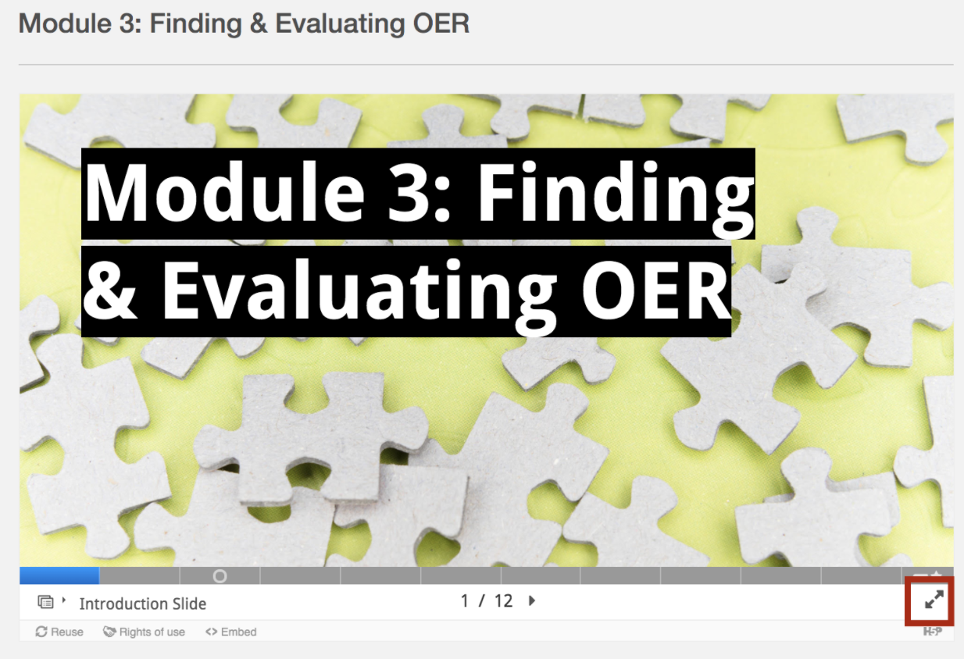

Step 3: When you complete the module, click Export Text to download a copy of the content you entered into the Module's text boxes.

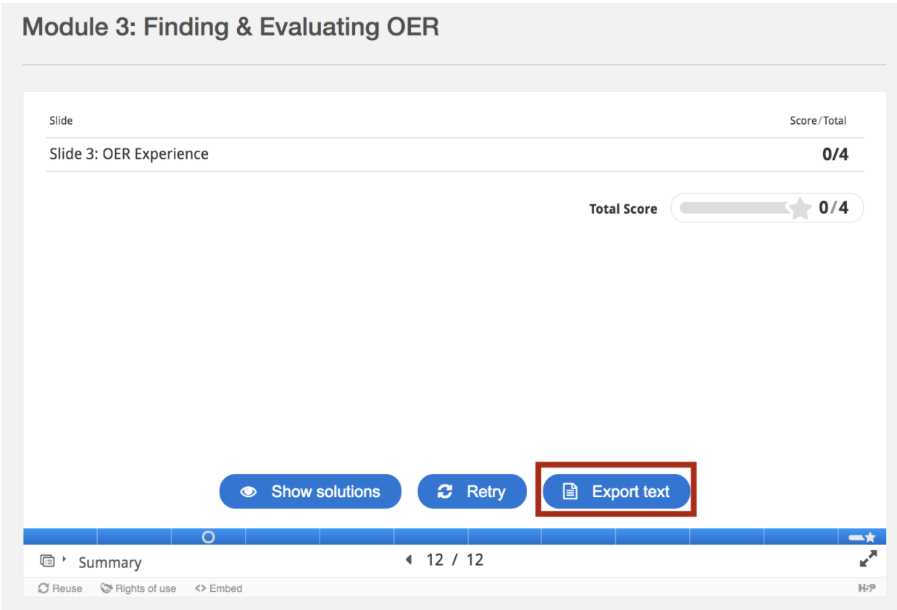

- Transcript for pre-recorded lecture videos in Module 3

Building Block Activity (Recommended)
Introduction:
During the pre-recorded lecture for Module 3, we discussed how to find and evaluate OER. This building block activity will help you find and evaluate OER that you can incorporate into your own AIF project.
Instructions:
Complete the Finding & Locating OER for AIF Projects Worksheet (approximately 20 to 30 minutes).
Optional:
Please consider posting your answers to Part 5: Reflect to the below Forum and also commenting on other participants’ answers.
Due Date:
August 4, 2020

Additional Resources
Detailed List of OER by Discipline:
McMaster Libraries’ OER By Discipline Guide
- This is an in-progress (open creation) that lists a broad range of OER organized by discipline at McMaster University.
Detailed Rubrics for Evaluating Open Resources:
BC OER Librarians' OER checklist
- This checklist is succinct, easy to follow, and can be used to evaluate a variety of OER.
Achieve's Rubric for Evaluating Open Education Resources Objects
- Achieve, an educational non-profit in the U.S., has developed a more extensive rubric to use when evaluating the appropriateness and quality of OER. This rubric uses 8 evaluation criteria.
iRubric's Evaluating OER rubric
- Developed by RCampus, a business focused on creating educational productivity tools, this rubric provides a list of recommended questions to ask yourself when selecting an OER.
BC Open Textbook Accessibility Toolkit
- While this open textbook helps OER content creators develop accessible resources, its accessibility checklist is a useful resource to consult when determining if an OER is accessible.
OER Evaluation Criteria by Affordable Learning Georgia
- This checklist is a list of questions that can be used to evaluate an OER.

Module 4: Depositing into YorkSpace

H5P Pre-recorded Lecture Materials
- H5P for Module 4: Depositing into YorkSpace
- Transcript for Videos in Module 4: Depositing into YorkSpace
- View-only version of Google Slide deck for Module 4: Depositing into YorkSpace

Warm-Up Activity (Recommended)
Please read the YorkSpace Tip Sheet (PDF) and complete the following questionnaire before viewing the pre-recorded lecture for Module 4. This task is recommended, but not required and will take no more than 10 minutes to complete.

Questionnaire for Module 4: Depositing into YorkSpace
Your answers to this brief questionnaire will only be viewed by the program facilitators.

Questionnaire:

- Have you ever used/consulted an item in YorkSpace or another Institutional Repository?

- Yes| No | Unsure

- Have you ever deposited content into YorkSpace or another Institutional Repository?

- Yes | No

- List any questions you have about depositing to YorkSpace that you hope will be answered in Module 4.

Pre-recorded Lecture (Required)
After you complete the pre-recorded lecture content, you will be able to:

- Describe the value of depositing your work into YorkSpace
- Create metadata for your AIF project that makes it more discoverable
- Learn how to deposit a copy of the open component of your AIF project into YorkSpace
- Describe accessibility best practices

Access Instructions for Pre-Recorded Lecture Materials:

Step 1: Go to the pre-recorded lecture content on eCampusOntario's H5P site.

Step 2: Click the double arrow button in the bottom-right corner to watch the module in full-screen mode.

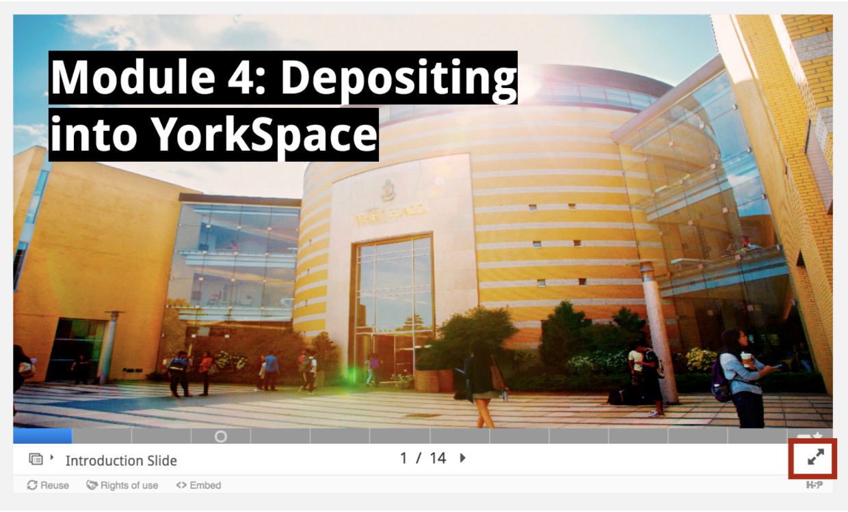

Step 3: When you complete the module, click Export Text to download a copy of the content you entered into the Module's text boxes. This will allow you to keep a copy of your answers.

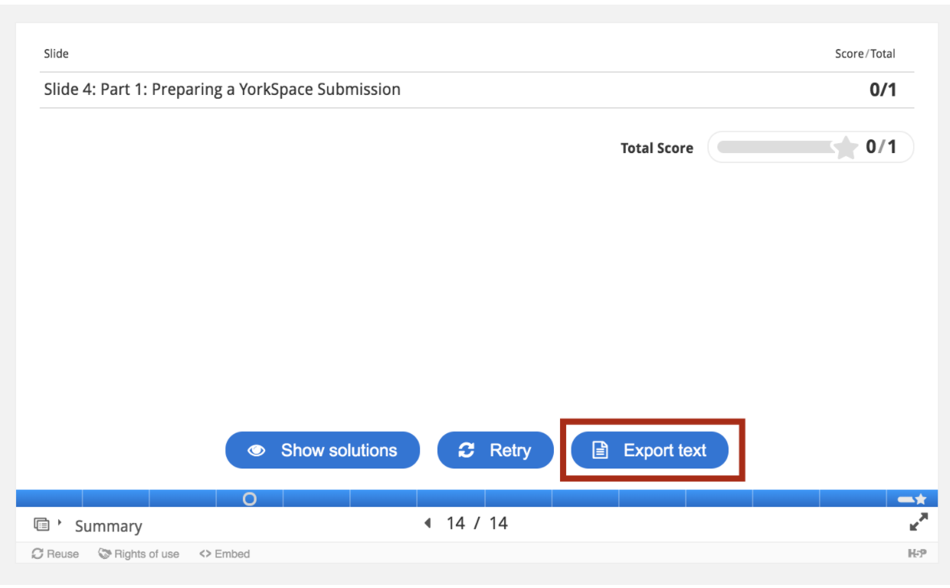

- Transcript for pre-recorded lecture videos in Module 4.

Building Block Activity (Recommended)
Introduction:
During the pre-recorded lecture for Module 4, we discussed how to deposit to YorkSpace. This building block activity will help you organize and collect information that describes the item that you would like to deposit into YorkSpace. This checklist is for unpublished items.
Instructions:
Complete the YorkSpace Template for Item Description worksheet (approximately 20 minutes).
Optional:
Please consider posting any questions that arise while completing the template to the below Forum.
Due Date:
August 11, 2020

Additional Resources
YorkSpace Resources:
- Access YorkSpace
- YorkSpace Resource Site
- YorkSpace Help for Editing items
Accessibility and Inclusivity:
- BC Open Textbook Accessibility Toolkit: This open textbook helps OER content creators develop accessible resources. Of particular interest may be:
  - Appendix C: Inclusive Design Webinar Series
  - Appendix A: Checklist for Accessibility.
Accessibility and Usability Considerations:

- Elder, A. K. (n.d.). Accessibility and Usability. In The OER starter kit. Iowa State University Digital Press. https://iastate.pressbooks.pub/oerstarterkit/chapter/accessibility/
Diversity and Inclusion:

- Elder, A. K. (n.d.). Diversity and Inclusion. In The OER starter kit. Iowa State University Digital Press. https://iastate.pressbooks.pub/oerstarterkit/chapter/diversity-inclusion/

