Pitches and Timbres in the Gamelan Kyai Parijata. ‘Exploring Sonic Design in Asian Traditional Music’ Session, Society for Music Theory Conference, St. Louis, October 29-November 1, 2015.

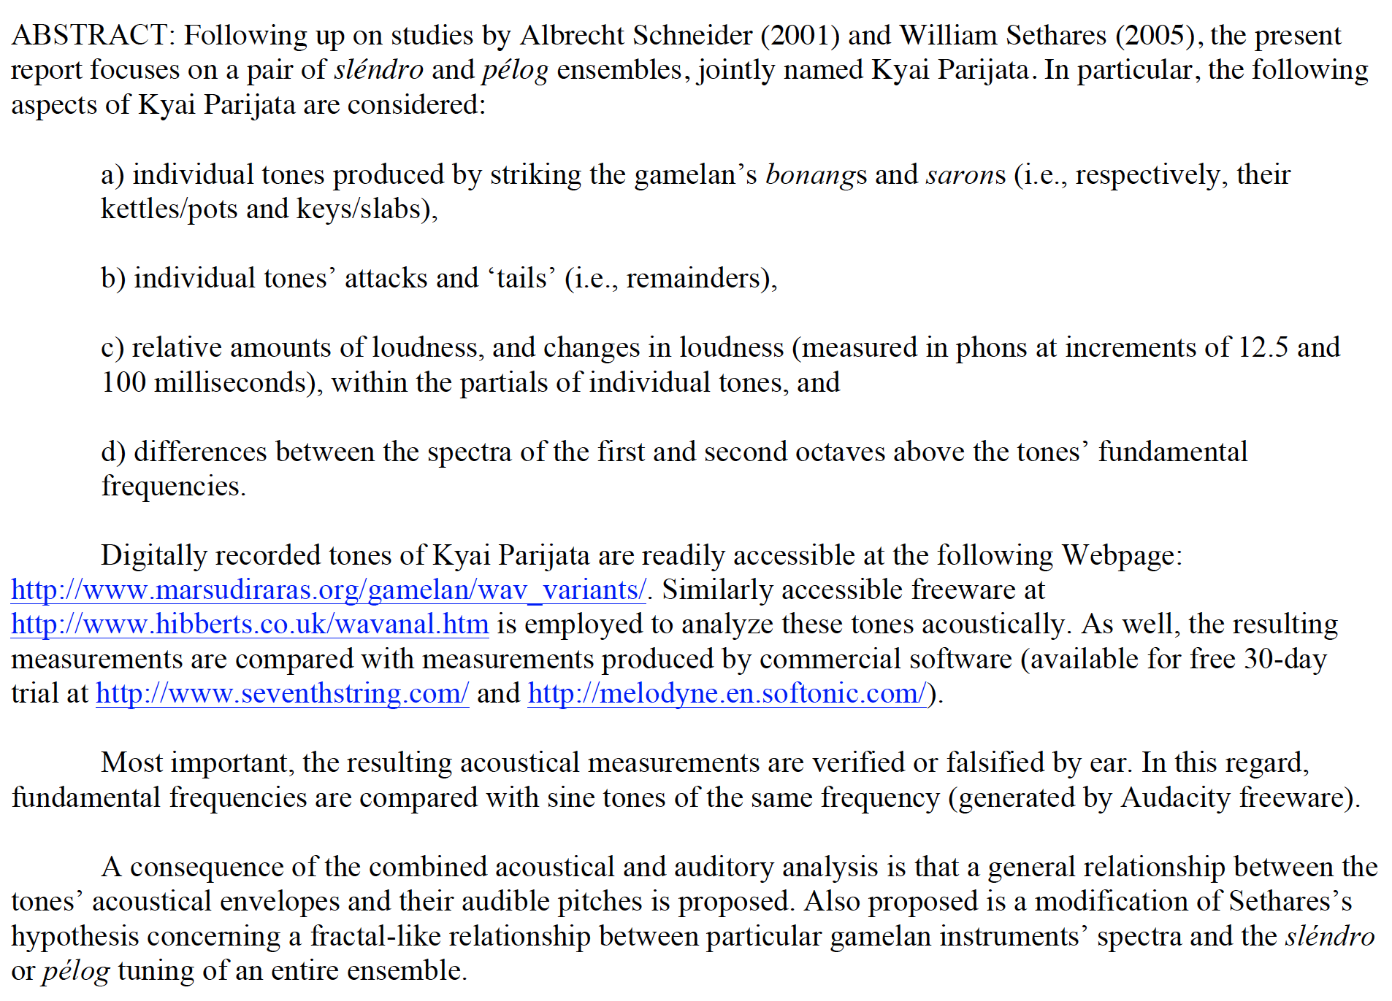

----------------------------------------------------------------------------------------------------------------------------------------

The present report focuses on tones produced by instruments in the gamelan Kyai Parijata, currently housed in the Dutch city of Delft. An important aspect of this research is that one should be able to verify or falsify its results quite readily. In this regard, the gamelan club that has employed Kyai Parijata, namely, Marsudi Raras, has posted online wav files of the individual tones the ensemble produces. Further, the software I have employed to analyze the spectra recorded in the wav files is widely available, either as freeware, or as almost-free ware.
In what follows, I focus on tones produced by the ensemble’s bonangs and sarons. (see Figure 1). Whereas the saron instruments generally play the principal melody of the heterophonic texture, the bonangs generally play countermelodies.
I begin with a consideration of the bonang tones’ fundamental frequencies and, of central importance to the larger research program of which this is a part, the pitches one hears in response to these tones. Thereupon, I consider the tones’ spectra in greater detail, as well as auditory correlates of their acoustical features before a brief discussion of the saron tones.

Figure 1. Bonang and saron instruments of Central Java.

a) Sléndro bonangs of Kyai Parijata comprise 12 ‘kettles’ or ‘pots’; pélog bonangs comprise 14.

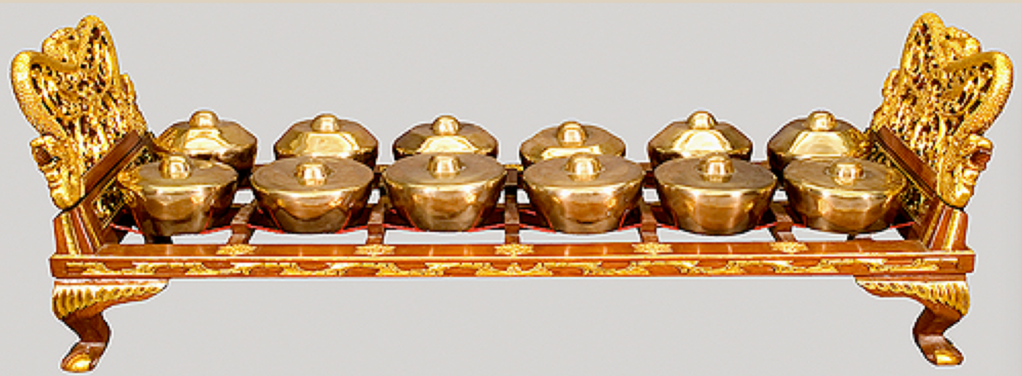

b) Sléndro and pélog sarons of Kyai Parijata comprise 7 ‘keys.’

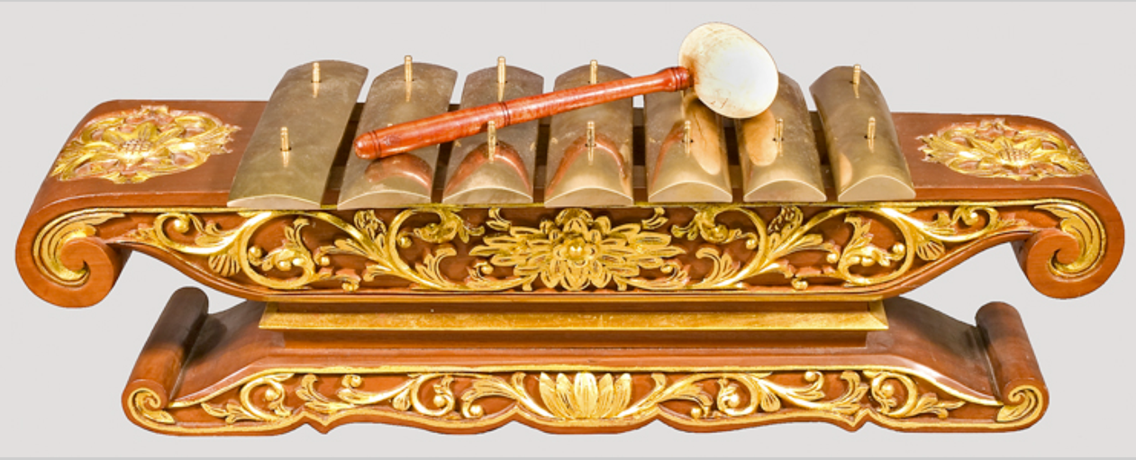

Fundamental Frequencies
To assess pitch and timbre, I installed wavanal freeware. (Since I use a Mac, it took about 2 hours to install wine freeware beforehand.) For each tone, wavanal produced a display of its constituent waves’ amplitudes at ~12.5-millisecond intervals for the first tenth of a second and at fifth-of-a-second intervals for the rest of the tone’s duration. As well, wavanal produced a summary display of all these component waves throughout each tone as a whole (see Figure 2 and listen to the tone on which it based: Audio 1).
For each tone, I compared the frequency wavanal identified as having the greatest amplitude or loudness with the value Melodyne software identified as the fundamental frequency (as displayed in Figure 3).
As shown in Figure 4, for all but four of Kyai Parijata’s 52 bonang tones, the Melodyne and wavanal values were within 5 cents of each other.

Figure 2. Loudness measurements (in phons) by wavanal software for the frequencies 535.5 Hz and 850 Hz produced by kettle 1 of the sléndro bonang barung in Kyai Parijata.

a) During the tone’s first 1/10th of a second, measurements are recorded every 1/80th of a second; thereafter, every 1/5th of a second.

time | 0.012 | 0.025 | 0.037 | 0.050 | 0.062 | 0.075 | 0.087 | 0.100 | 0.1 | 0.3 | 0.5 | 0.7 | …
535.5 Hz | 71.09 | 77.73 | 86.58 | 93.55 | 95.27 | 93.94 | 91.14 | 87.42 | 87.41 | 33.46 | 11.64 | 3.40 | …
850 Hz | 1.16 | 1.66 | 1.79 | 1.66 | 1.53 | 1.48 | 1.43 | 1.39 | 1.39 | 0.83 | 0.51 | 0.37 | …

b) Summary loudness measurements for the frequencies 535.5 Hz and 850 Hz during the entire duration of the tone produced by kettle 1.

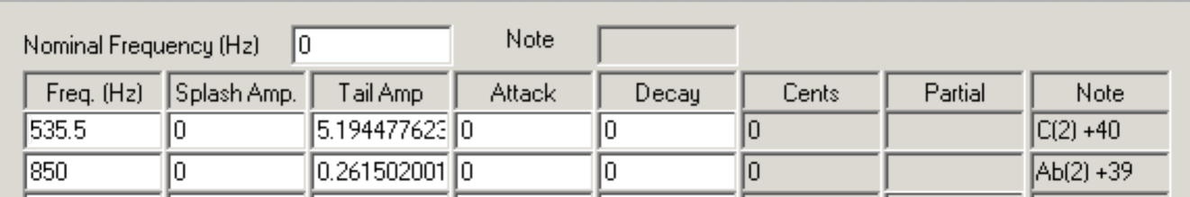

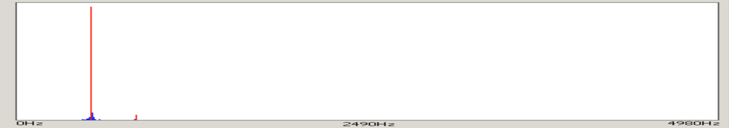

Figure 3. Sléndro bonang barung kettle 1’s loudest frequency and fundamental frequency as measured by wavanal and Melodyne.

a ) According to wavanal, the loudest frequency is 535.5 Hz, i.e., C5+40 cents (reported relative to middle C4, as C(2)+40 (cf. Figure 2):

b) According to Melodyne, the fundamental frequency is C5+39 cents (reported as C5 + 39 ct):

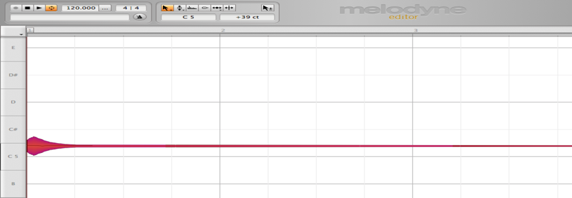

Figure 4. Measurements of loudest frequency and fundamental frequency by wavanal and Melodyne for all 52 bonang tones in Kyai Parijata.

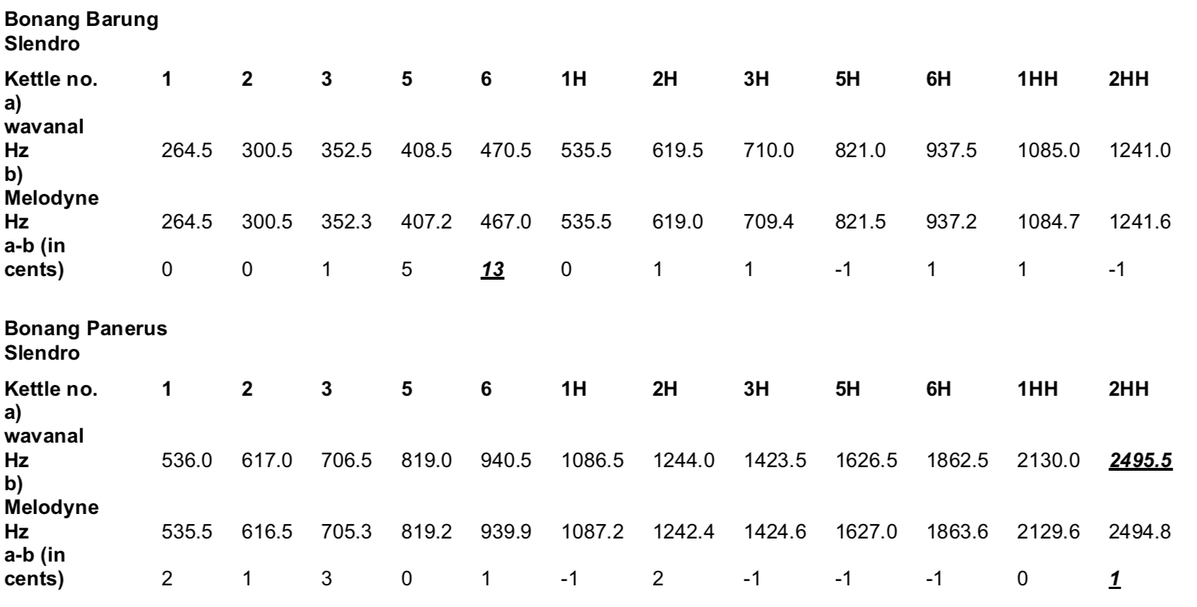

Figure 4 (cont’d).

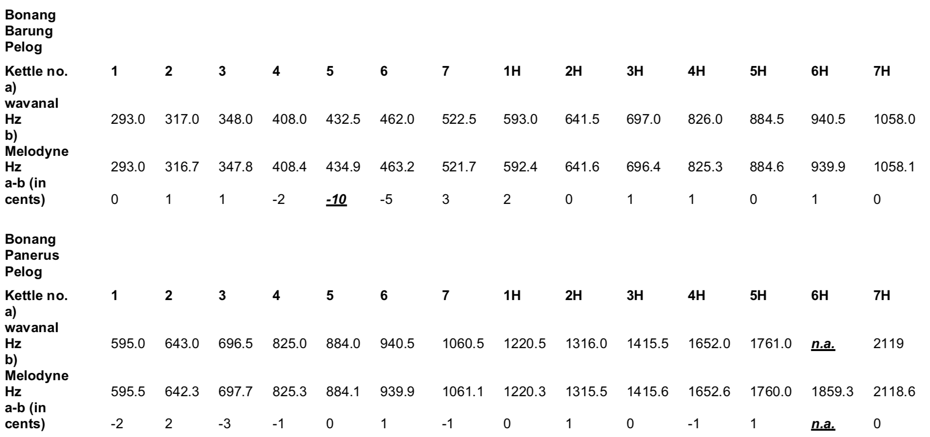

Among these four, wavanal produced a bewildering display for the bonang panerus pélog tone 6H. According to wavanal’s display the loudest component frequency was about a 13th below its counterpart in Melodyne’s display, and about a 13th below what one would expect to hear. As it turned out, Melodyne displayed a frequency close to wavanal’s loudest frequency as a subsidiary to the frequency Melodyne depicted as the tone’s loudest partial. Moreover, as Figure 5 shows, the loudest frequency in the display produced by Transcribe! software was close to Melodyne’s loudest frequency, in fact within 2 cents. Evidently, then, there was a difference between the ways in which, on one hand, Melodyne and Transcribe!, and on the other hand, wavanal, arrived at their determinations of these two tones’ fundamental frequencies.

Figure 5. Analyses of Kyai Parijata’s bonang panerus pélog 6H tone by a) wavanal, b) Melodyne, and c) Transcribe! software.

a) wavanal
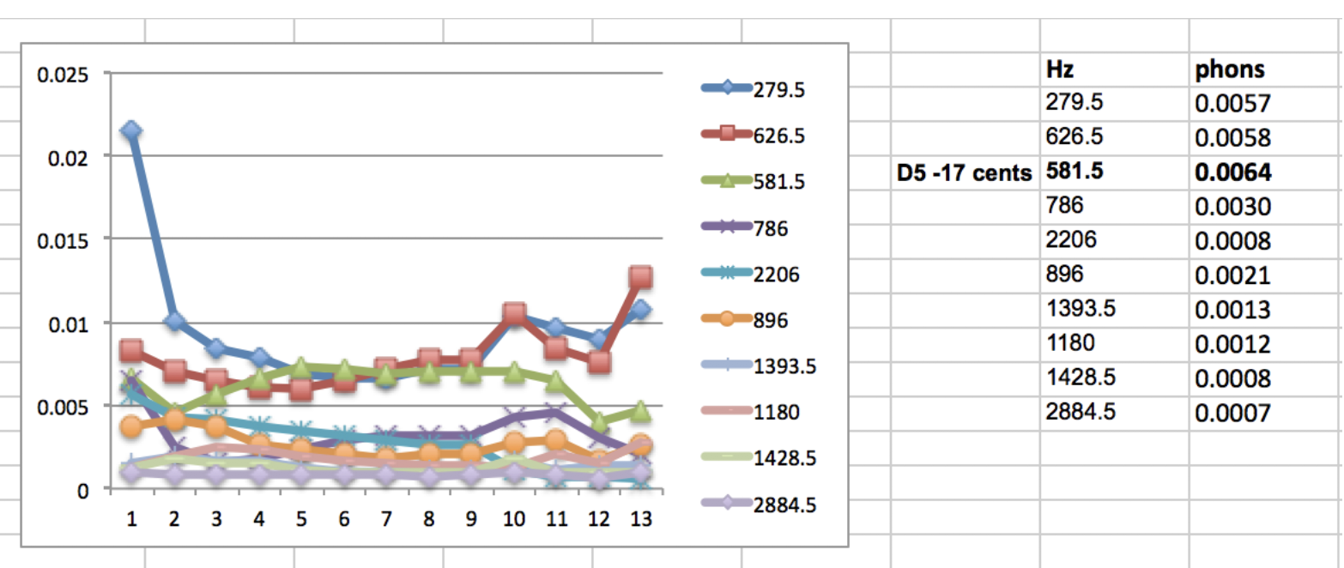
Figure 5 (cont’d).
b) Melodyne
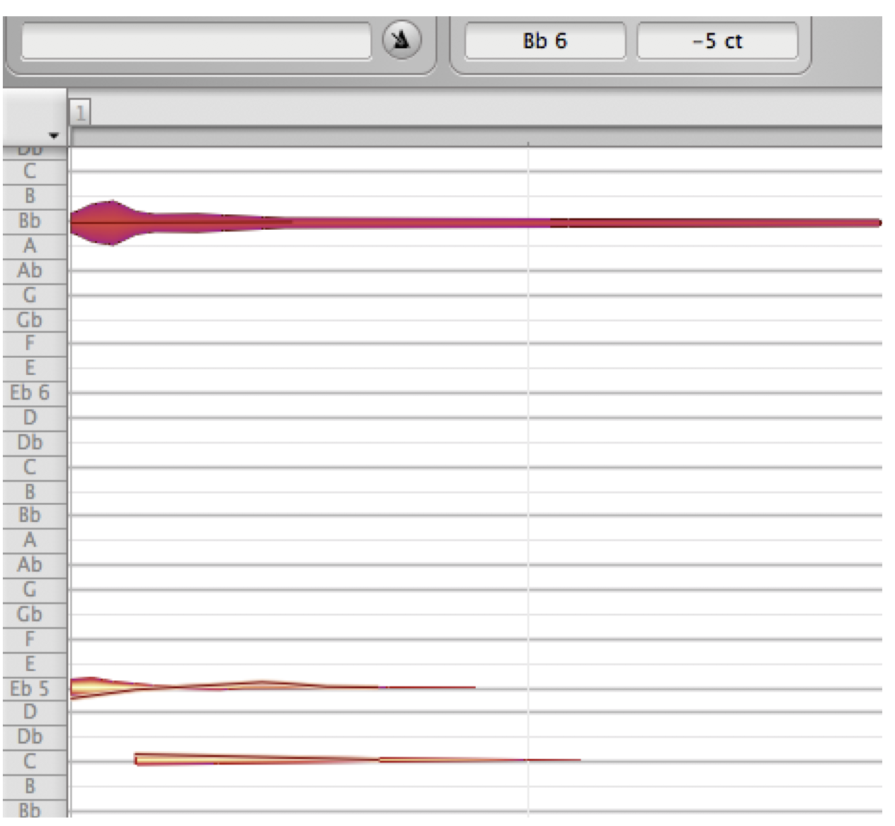
c) Transcribe!

Of the discrepant measurements, the greatest difference involved the sléndro bonang panerus tone 2HH. Nonetheless, although wavanal displays a frequency of 80 Hz as loudest over all, 2495.5 Hz is second loudest overall and loudest at the tone’s beginning. Most important, as I shall discuss presently, I heard the bonang panerus 2HH tone as being the same in pitch as a sine tone having Melodyne’s fundamental frequency 2496.2 Hz, rather than wavanal’s value of 80 Hz. Accordingly, I regarded the Melodyne values for such tones as their fundamental frequencies for the next preliminary step in the analysis.

Pitches
Most important for the present study, I considered the fundamental frequencies I had identified for the bonang tones merely as potential surrogates for the tones’ pitches rather than as the tones’ pitches per se. In order to identify a perceptually-based surrogate instead of a value that was merely acoustical, I avoided relying solely on the loudest wave within a spectrum or on general findings in psychoacoustics, and proceeded as follows.
As a first, heuristic step in identifying a perceptually-based surrogate for the pitch of an entire tone, I employed Audacity freeware to generate a sine tone having the same frequency as the frequency of the wave that, according to Melodyne (and corroborated by wavanal or Transcribe!) had the greatest loudness or amplitude in the tone as a whole. Then I listened to the original gamelan tone and the generated sine tone in close succession to judge whether they were the same in pitch. Since I have made all these parts of the study accessible online, others can determine for themselves whether each of my pitch judgments is justified. And if one’s own pitch judgment conflicts with my pitch judgment, one can generate a sine tone that verifies their pitch judgment and post it online.
For my part, I managed to generate a sine tone that, for me, matched in pitch each of the 52 bonang tones. For 42 of the 52 bonang tones, i.e., ~81%, I perceived no difference in pitch between a particular bonang tone and a sine tone having the same frequency as the fundamental frequency Melodyne had determined for it. It should be noted that differences of 5 cents or less between the Melodyne frequencies and the auditory sine-tone frequencies were a result of the fact that Melodyne’s values shift slightly from one analysis to another. In any event, for the exceptional tones, which are highlighted in Figure 6 I proceeded by trial and error, employing Melodyne to raise or lower the frequency of a sine tone until it matched in pitch a particular bonang tone.

Figure 6. Melodyne’s values for fundamental frequencies of Kyai Parijata’s 52 bonang tones compared with frequencies of sine tones I heard as matching these tones in pitch and the difference between these values in cents.

a) Sléndro bonang barung
b) Sléndro bonang panerus
c) Pélog bonang barung
d) Pélog bonang panerus
In audio example 2, bonangbarungsl2l is followed by a sine tone having the same fundamental frequency; then bonangbarungsl2l again, but this time followed by a sine tone with a higher fundamental frequency that I heard as the same in pitch. (Audio 2)
None of the exceptions occurred among the 26 bonang panerus tones, not even in the tones that had resulted in wavanal’s strange displays. Instead, each of the exceptions occurred among the 26 bonang barung tones, and generally among the bonang barung’s lower tones. Moreover, all of their sine-tone adjustments were upward. That is, I heard these bonang barung tones as higher than the software specified.
With regard to pitch, then, one can offer the following observations concerning Kyai Parijata’s bonangs. None of the 52 tones is intractable with respect to pitch. For by far the majority of tones, a fundamental frequency identified by standard, free (or almost-free) software corresponds to the pitch of a sine tone having the same frequency. In instances where there is a substantial discrepancy, the sine tone’s frequency is higher than the software suggests. Further, such substantial discrepancies occur in the lower, barung bonangs rather than in the higher, panerus bonangs, and the largest discrepancies tend to occur among the lowest tones of the bonang barungs.
To be sure, some of these discrepancies are quite large: as much as 75 cents. Like Albrecht Schneider, one might be tempted to regard these largest discrepancies as invalidating the relevance for our understanding of sléndro and pélog tunings those studies that, for more than a century, have identified the pitches of gamelan tones with their fundamental frequencies. However, such a negative claim would depend, in turn, on how one might formulate sléndro and pélog themselves: a topic I have addressed in previous studies.

Upper Partials
Bill Sethares has proposed a way of analyzing relationships between a bonang tone’s upper partials and the sléndro tuning in which it is employed. In his widely cited book Tuning, Timbre, Spectrum, Scale (at a recent count, 356 citations in Google Scholar), Sethares says, “The sléndro scale [i.e., the sléndro tuning] can be viewed as a result of the spectrum of the bonang in combination with [the first 4 partials of] a harmonic sound,” and “The partials of the [bonang tones] are consistent across each gamelan.” However, among the more than 100 hundred bonang tones he says he analyzed, Sethares has provided detailed measurements of the upper partials for only 3. Nonetheless, he has claimed more precisely that “a good generic bonang spectrum” comprises three prominent (i.e., relatively loud) upper partials that are, in order of decreasing amplitude (or loudness), approximately 725, 2149, and 2383 cents above its fundamental frequency, as shown in Table 1.

Table 1. Number of cents between the fundamental frequency and the loudest partials above it in bonang tones according to Sethares (2005, 207-08), and a comparison with an idealized sléndro tuning.

partials above fundamental frequency:
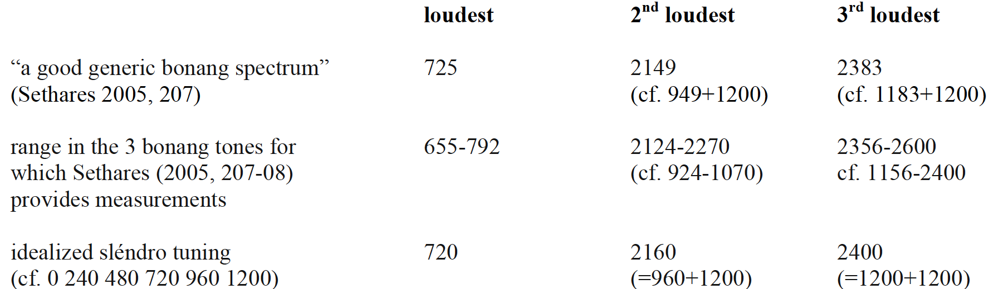

Here it should be noted that an idealized sléndro tuning would comprise intervals of 240, 4800, 720, 960, and 1200 cents. In this regard, 725 cents would be close to 720 cents, whose octave complement would be 480 cents. 2149 cents would be close to 2160 cents (i.e., 1200+960 cents), and the octave complement of 960 cents would be 240 cents. Moreover, 2383 cents would be close to 2400 cents (i.e., 1200+1200 cents); as well, 1200 and 2400 cents would also be the 2nd and 4th partials of an idealized harmonic sound’s overtone series. In any event, the only three bonang tones for which Sethares has published actual measurements comprise the ranges outlined in Table 1 for the frequencies of a bonang tone’s upper partials.
To the extent that the bonang tones’ upper partials were close to such ideal values as 720, 2160, and 2400 cents they would support the notion that bonang tones bear a fractal relationship to sléndro tuning as a whole, for their individual spectra would be micro-structural correlates of the macro-structural tuning of an entire ensemble. To what extent, then, are the prominent upper partials of the bonang tones in Kyai Parijata close to the ideal frequencies and to the ranges of the frequencies of the loudest upper partials that Sethares has reported?
As an initial step in answering this question, I examined wavanal’s spectral displays and aligned the 52 bonang tones’ upper partials in descending order of loudness. I found that in a great majority of the 52 tones (specifically, 46 of the 52) the second loudest partial occurred within the first register above the fundamental frequency, i.e., less than 1200 cents above the fundamental. However, with regard to Sethares’s generalization concerning bonang tones, the most prominent upper partial in these 46 tones was generally not very close to 720 cents above the fundamental. Instead, as Table 2 shows, the values of these partials ranged from approximately a major 2nd to almost a perfect octave above the fundamental.

Table 2. Loudest partial above the fundamental frequency in bonang tones of Kyai Parijata.

tuning no. of kettles cents above fundamental frequency

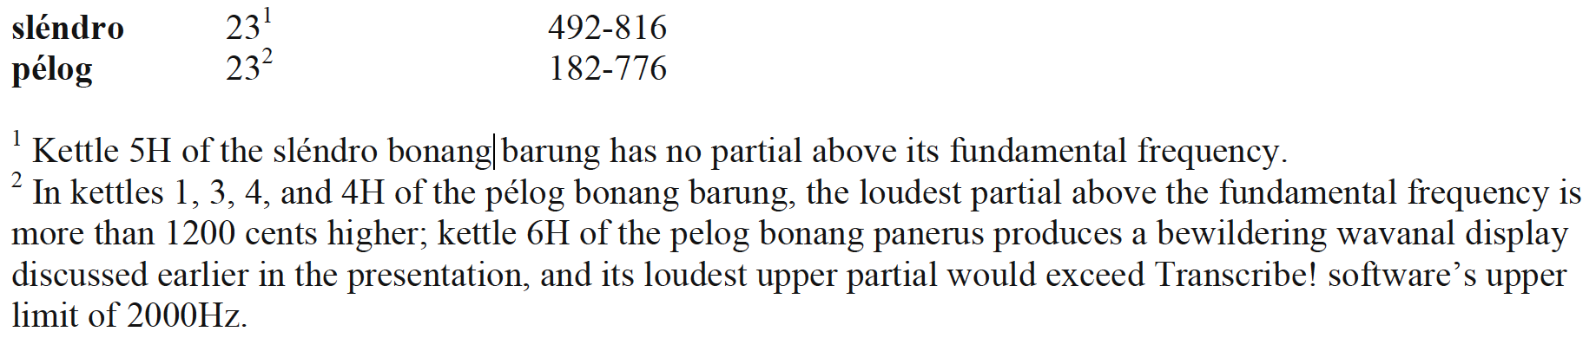
Rather than being close to an idealized sléndro 5th of 720 cents, which would support Sethares’s notion that the spectra of sléndro bonangs would reduce sensory dissonance among the tones of an entire ensemble, the most prominent upper partials support a very different pair of conclusions.
First, their appearance within the first octave results in a relatively dull, muffled timbre in contrast to all but one of Kyai Parijata’s 35 saron tones, which also last much longer than its bonang tones. In 18 of the 35 saron tones, the most prominent upper partials are more than 1200 cents above the fundamental, resulting in a relatively bright timbre as in the second of the following pair of audio examples (Audio 3).
In 6 saron tones, the most prominent upper partials are close to 1200 or 2400 cents above the fundamental, resulting in a clear timbre, and after the onset in the remaining 10, there is no upper partial at all, resulting in the timbre of a very loud tuning fork.
To be sure, the most prominent upper partial in 10 of Kyai Parijata’s 35 saron tones appears in the 2nd octave above the fundamental: specifically, from 1590 to 1849 cents above and in general conformity with Sethares’s account, as shown in Table 3. However, in 6 saron tones the most prominent partial appears in the 3rd octave above, whereas such high partials are not the most prominent in Sethares’s illustrative measurements. And finally, the loudest upper partial of 2 tones appears in even higher octaves: one in the 4th octave above the fundamental, and one in the 6th. In sum, then, Kyai Parijata’s bonang tones do not support a clear relationship between timbre and tuning of the sort that Sethares has advanced. Nevertheless, they support the idea that bonang tones differ considerably in timbre from saron tones.

Table 3. Prominent upper partials of 4 saron keys in 2 gamelan measured by Sethares (2005, 203-04).

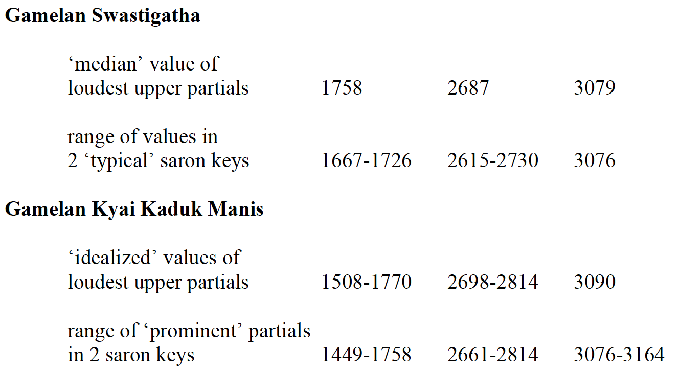

Second, the appearance of most prominent partials throughout most of the first octave above most bonang tones’ fundamental frequencies and throughout much of the second octave above in several saron tones would tend to distribute sensory dissonance quite widely throughout the ensemble as a whole rather than removing it from individual scale degrees. Indeed, Sethares himself has rightly drawn attention to another, recurrent aspect of upper partials—and of some fundamentals—that supports the idea of widely distributed sensory dissonance: specifically, that often a particular partial is accompanied by another partial that is quite close to it in frequency. In Kyai Parijata, such neighbouring partials tend to be of much smaller amplitude or loudness, resulting in what one might term a ‘scintillating’ beating or roughness between the pair.
For instance, in the following bonang tone, one can clearly hear the most prominent, but somewhat noisy, upper partial about a perfect 5th above the fundamental, as shown in Figure 7. In real time, this upper partial differs from its less energetic sibling by about 30 Hz, resulting in pronounced roughness. Slowed down to a third of its playback speed, one can hear this roughness transformed into something like beating at a rate of about 10 Hz, i.e., about 10 per second. (Audio 4)

Figure 7. Fundamental frequency, loudest upper partial, and its sibling partial in the sléndro bonang barung 3 tone of Kyai Parijata as displayed by Transccribe! Software: horizontal line indicate decibel levels below 0 dB.
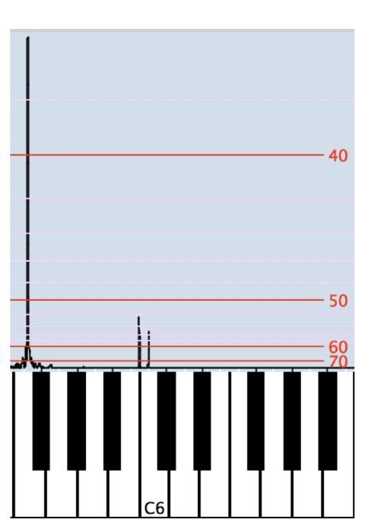

To conclude briefly:
- In general, i.e., for almost 90% of the bonang tones and all of the saron tones, the fundamental frequency provides an effective heuristic basis for identifying a tone’s pitch.
- None of the tones’ pitches is perceptually intractable.
- The relatively few tones in which the relationship between fundamental frequency and pitch is anomalous occur among the lowest bonang tones, tend to be heard as higher than acoustical measurements would suggest. They do not substantially affect the sound of simultaneous dyads, which tend to beat slowly, if at all, throughout the entire ensemble. Moreover, they indirectly vindicate more than a century of tone measurements that overwhelmingly focus on sarons rather than bonangs.
- The spectra of bonang and saron tones do not support Sethares’s claim concerning their relationship with sléndro and pélog tunings as a whole.
- Instead, the bonangs’ spectra and envelopes support the conclusion that their timbres contrast clearly with the sarons.
- Finally, the spectra of both kinds of instruments tend to distribute roughness throughout an ensemble’s range rather than converging on the fundamental frequencies of other tones in its tuning.

References Cited
